SWAPZY – PLAY & TRADE

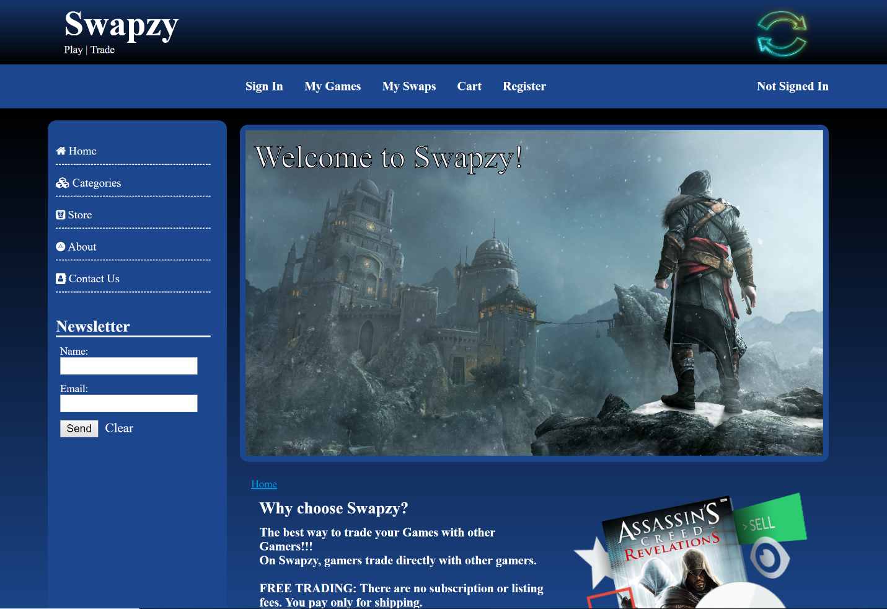

# ITIS 5166 - Network-Based Application Development

# Under guidance of Dr. Nadia Najjar

|  |  |  |
| --- | --- | --- |
| Student Id: 801078023 | Name:Gunjan Kushwah | Semester:Fall 2018 |

TABLE OF CONTENTS

|  |  |  |
| --- | --- | --- |
|  | Introduction | 3 |
|  | Home | 4 |
|  | Sign In | 5 |
|  | Register | 8 |
|  | Catalog Category | 11 |
|  | Items | 13 |
|  | Swaps | 15 |
|  | My Games | 19 |
|  | * 1. Add New Item | 22 |
|  | * 1. Feedback | 25 |
|  | My Swaps | 27 |
|  | About & Contact | 30 |
|  | Sign Out | 31 |
|  | Footer & User Manual | 33 |
|  | Database Design | 34 |

INTRODUCTION

Swapzy is a web-based application designed to provide a platform to the gamers, to trade games online. Swapzy provides a way for all gamers to come on a single platform and exchange games with one another directly. The user has to login to the system to see the swap offers, games available for swap.

The web application is designed in a way that provides easy access to its users. The user and site navigations are designed in a simple way to provide an easy navigation through out the application.

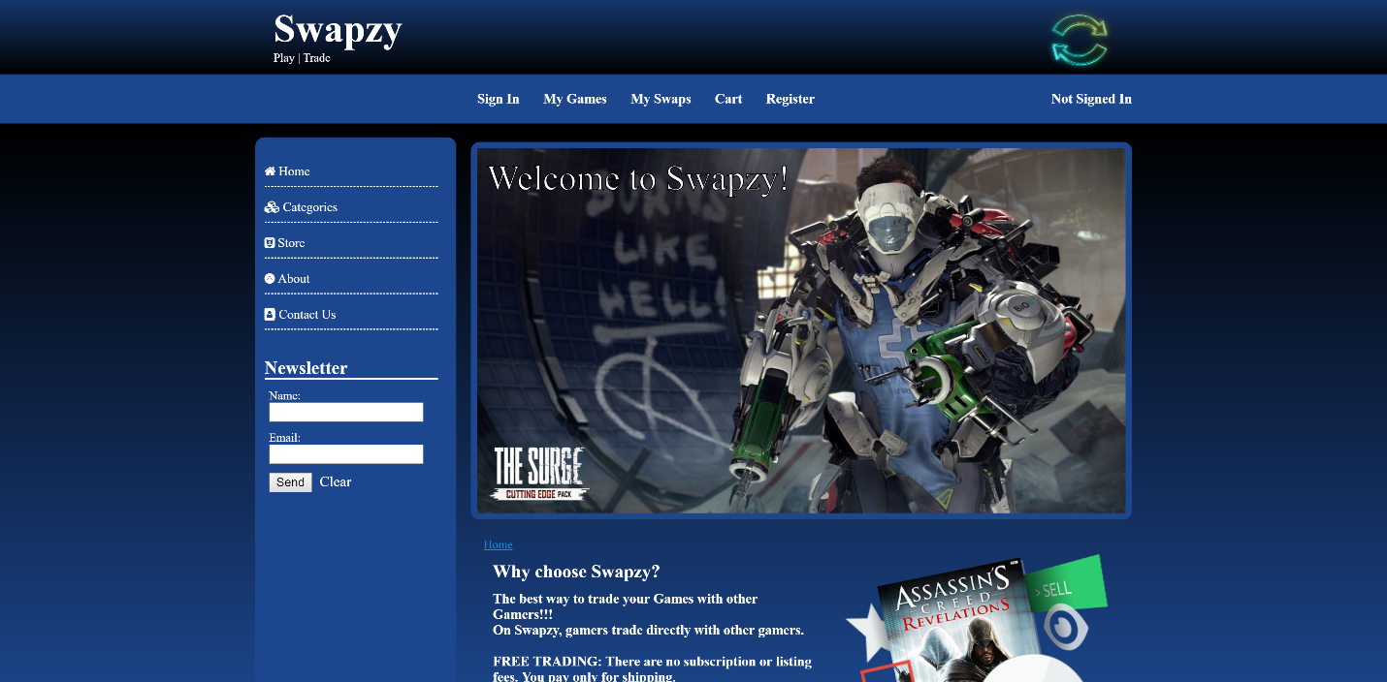

The user can login to the application and navigate to the catalog page where it can view different kinds of categories of games available and each category containing a list of few items in them. The login page needs the user to sign in with its credentials: i.e. the User ID and the password. Once the user is signed in he/she can navigate to My Games, My Swaps, Swaps, Items, Catalog Page to make changes as per their need.

HOME

The home page consists of a brief overview of the website. The home page consists of the logo/ branding of the website as per the requirements. Place holder for login name, breadcrumbs for current page, user-navigations and site-navigations along with footer.

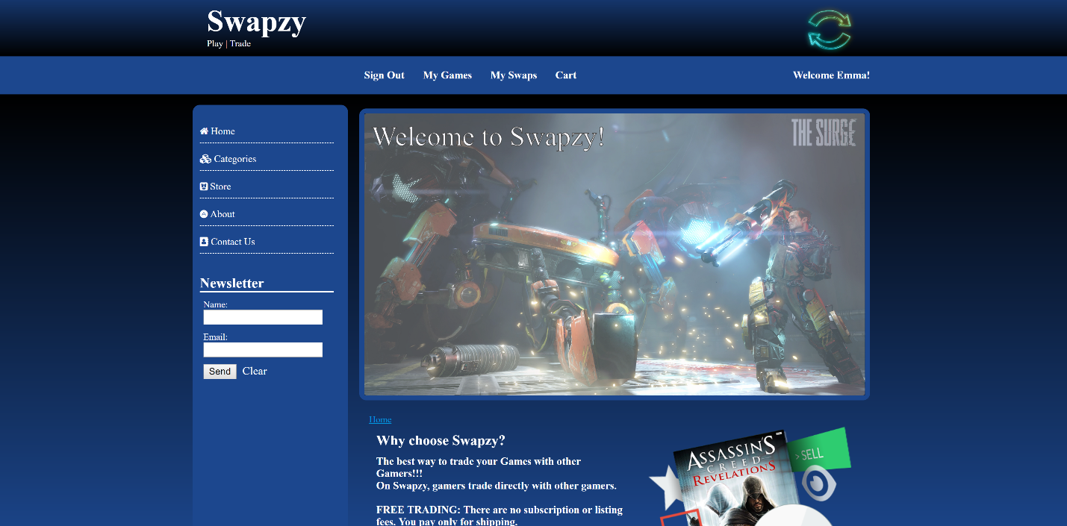

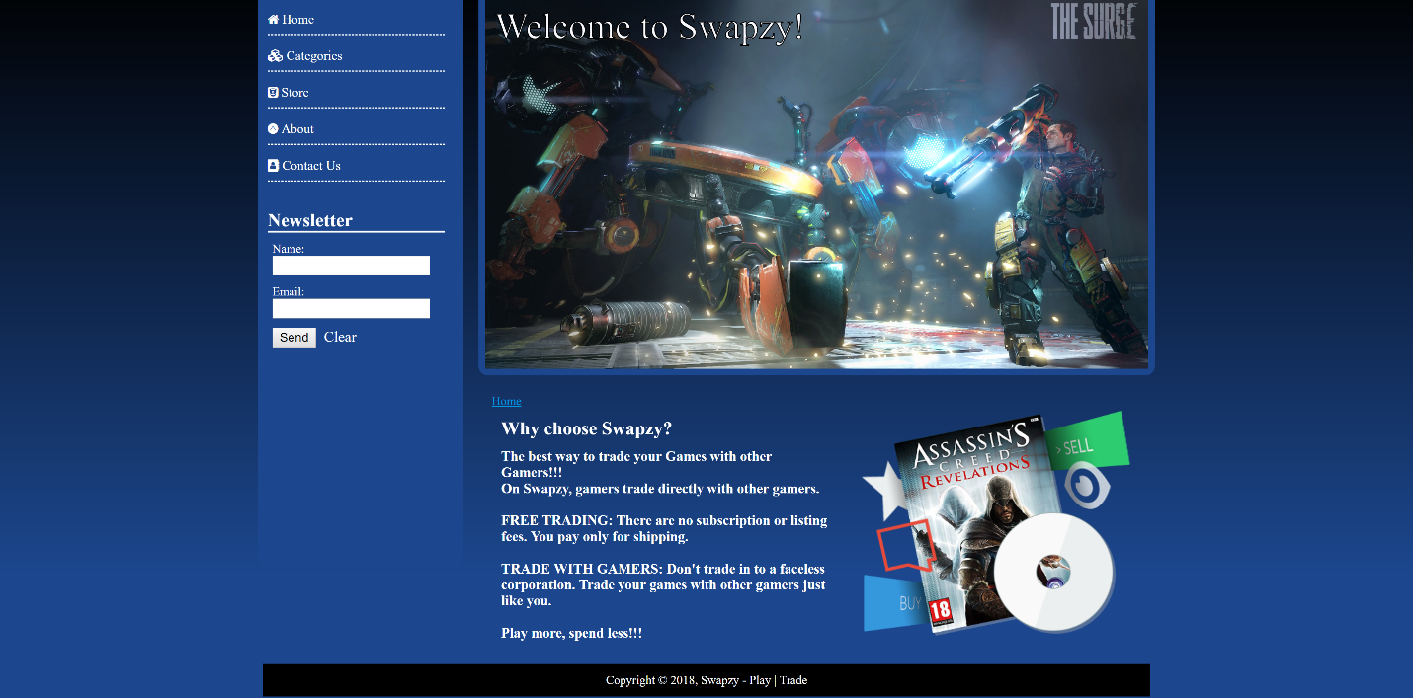

SIGN IN

The Sign In page consists of a basic form with – User ID and Password fields. The two mandatory details needed for a user to sign in. If the data doesn’t match with the one in database, it throws an error saying Invalid or no User/Password provided. If user ID or password is not entered it gives field specific error. If User ID format is incorrect it gives validation errors as shown below:

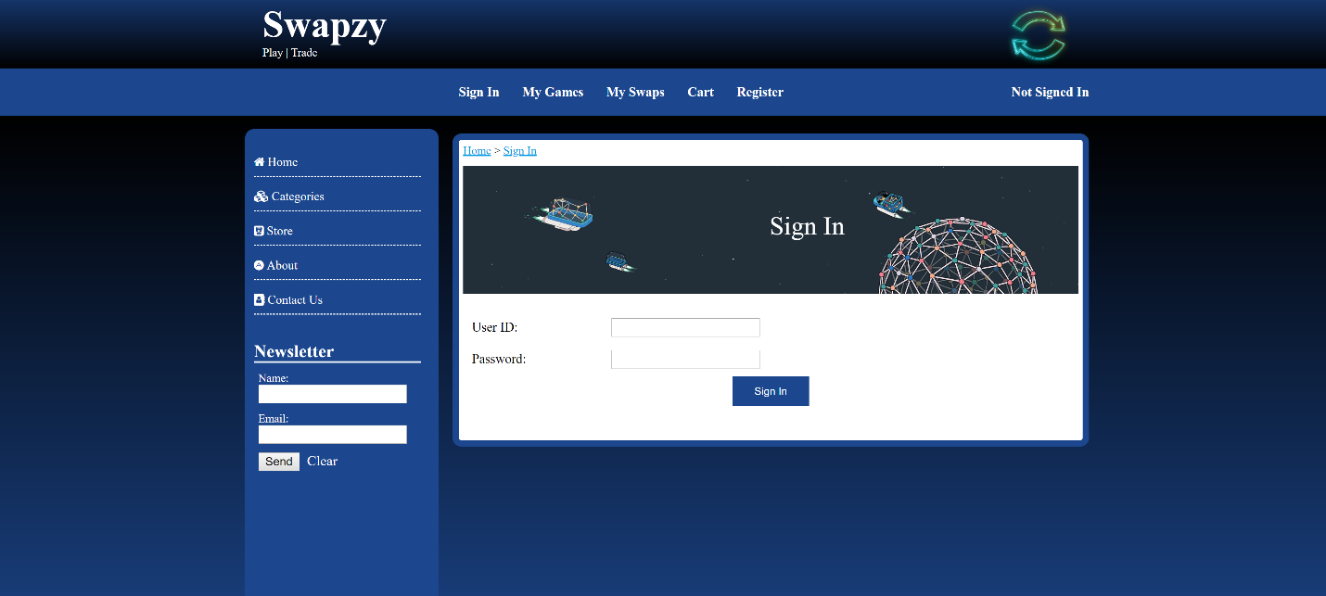

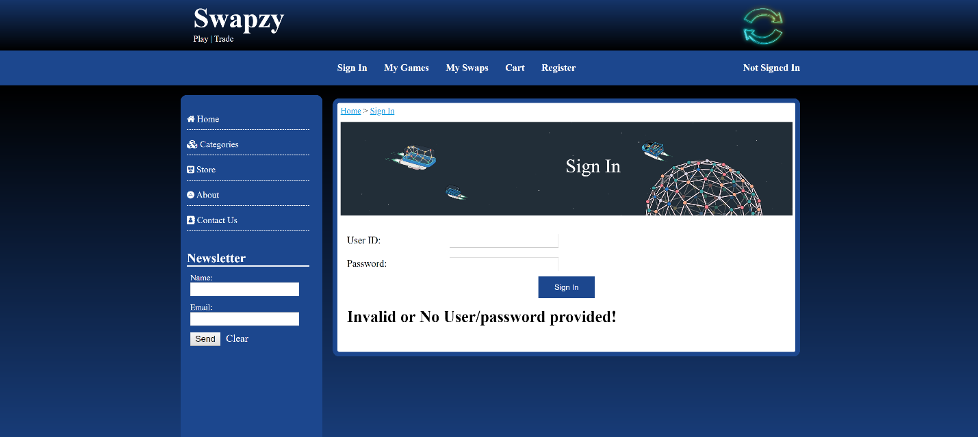

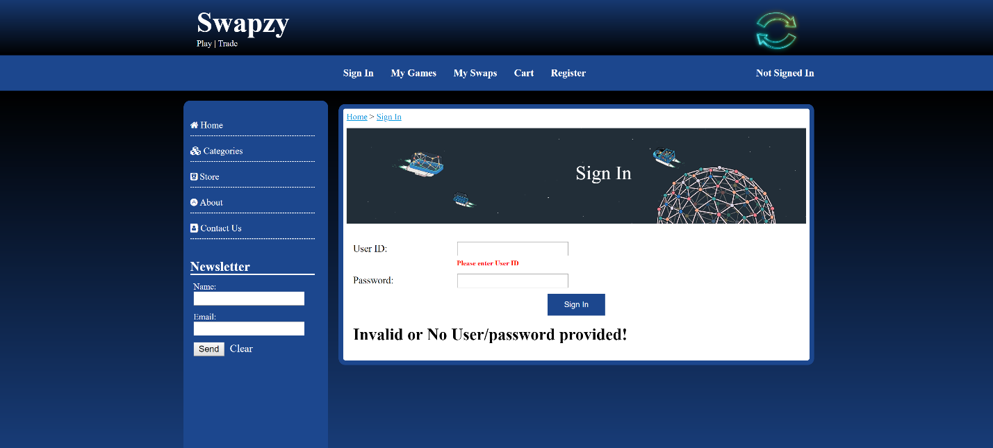

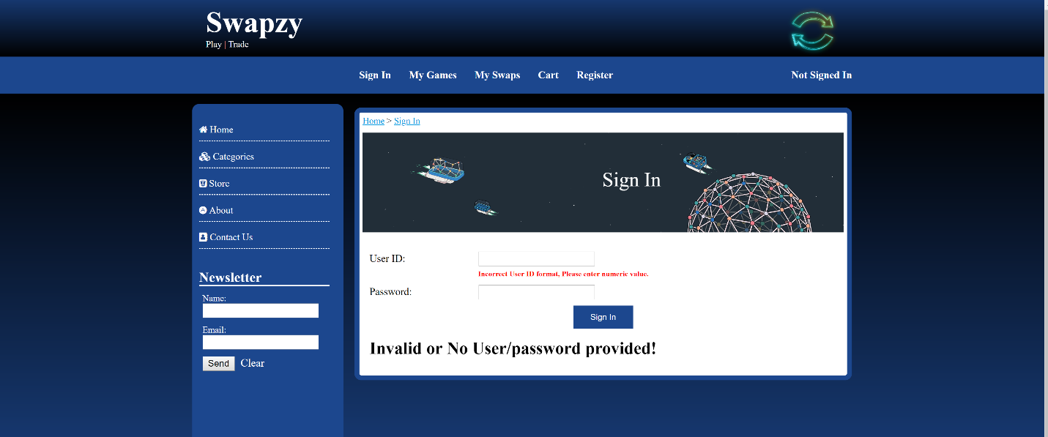

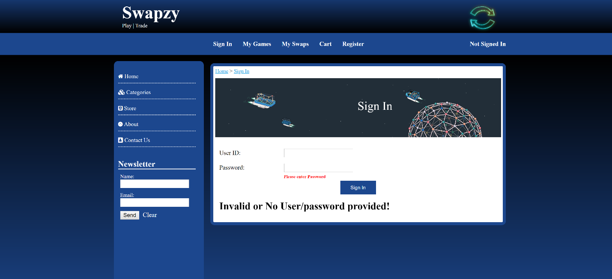

On correct user ID and password input – It shows a welcome user message as shown below:

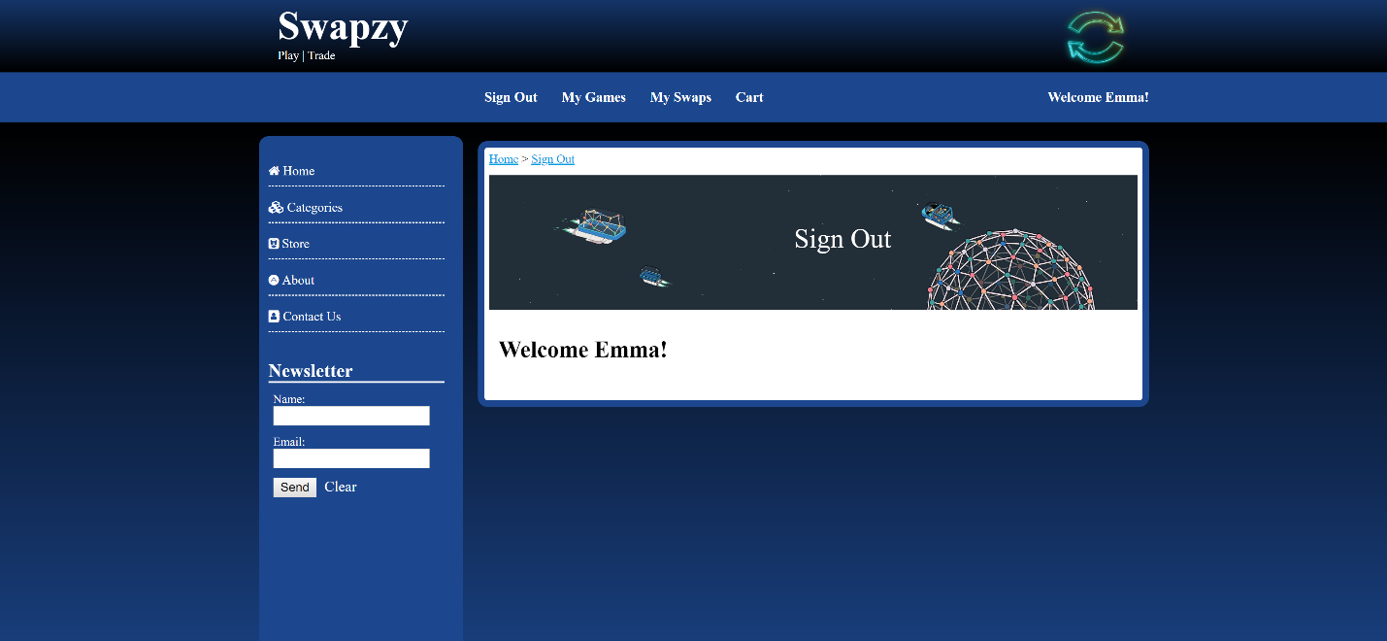

REGISTER

The register tab on the website, provides the functionality to register for the website. Once a user registers, his details are entered in the database. The below is the UI for the registration page and validations on the screen:

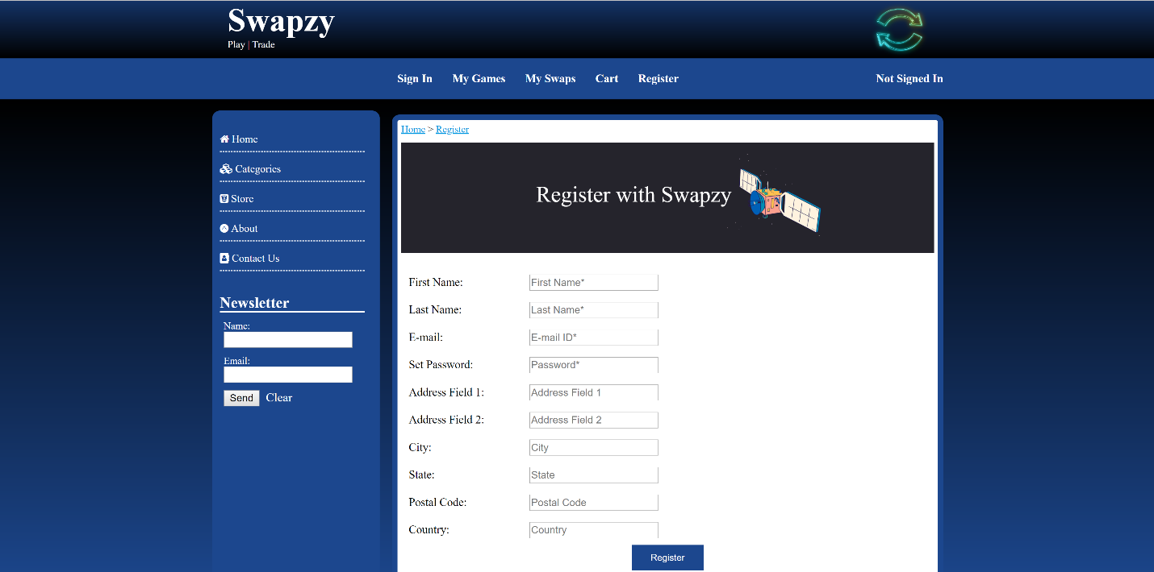

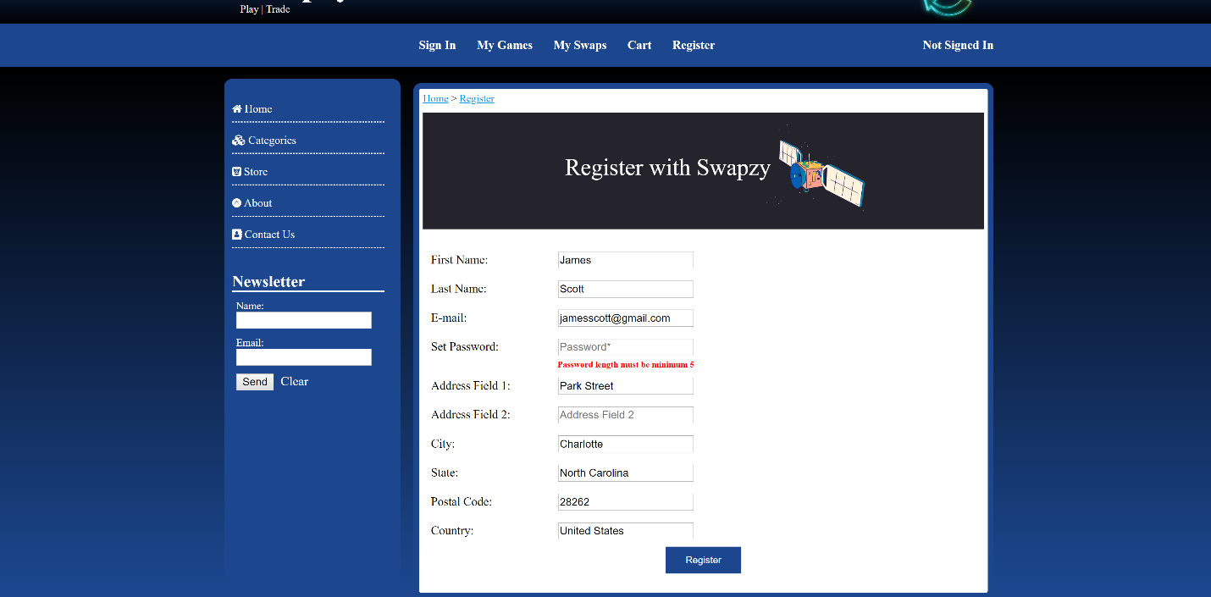

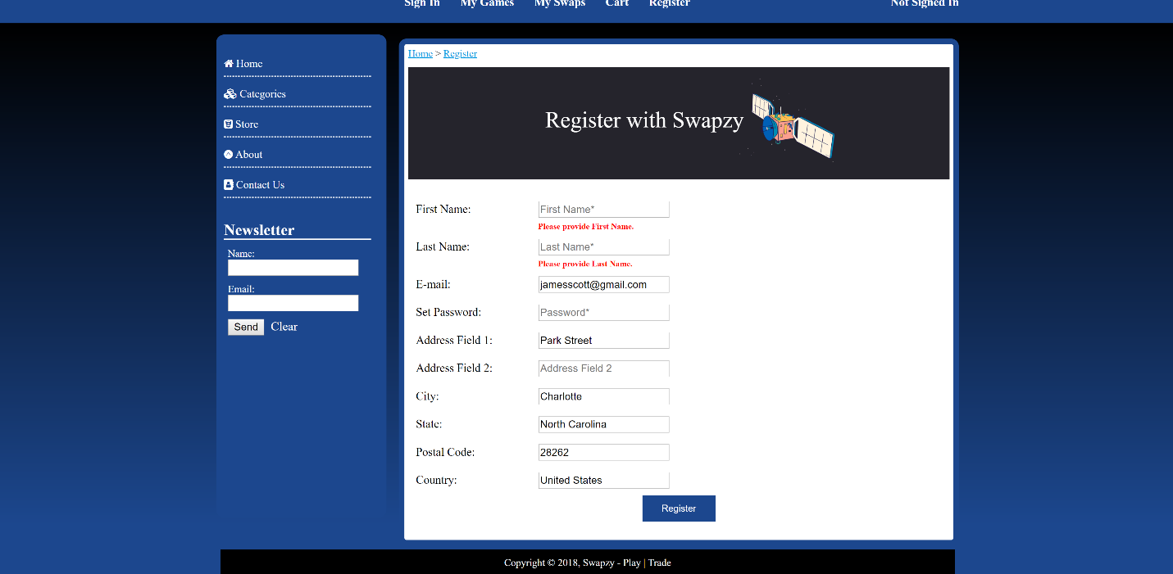

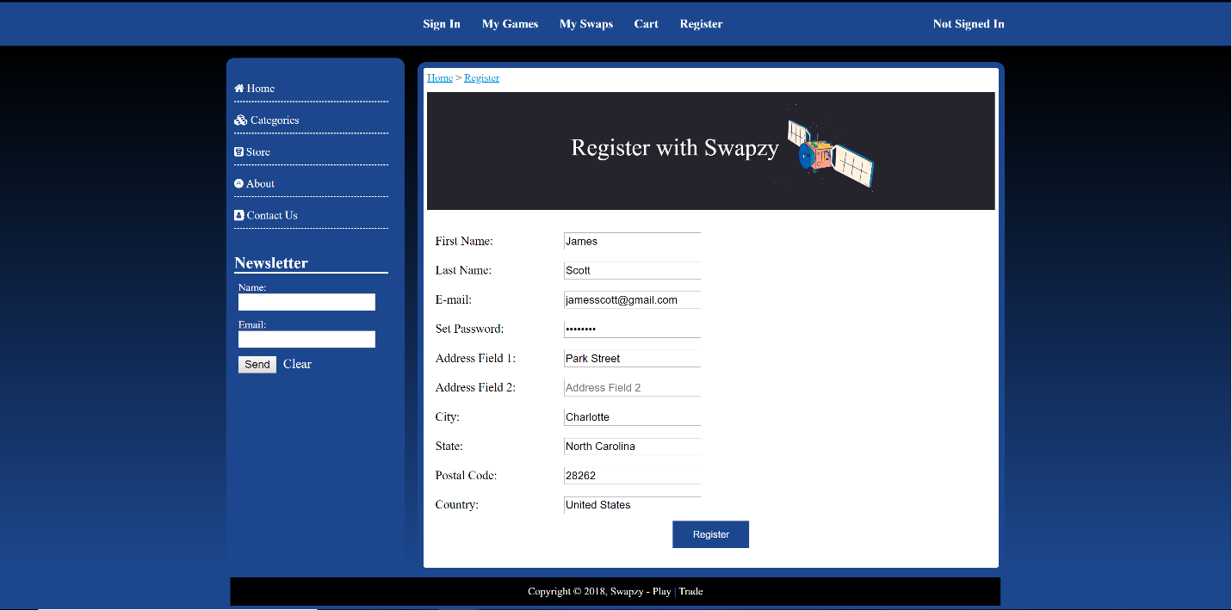

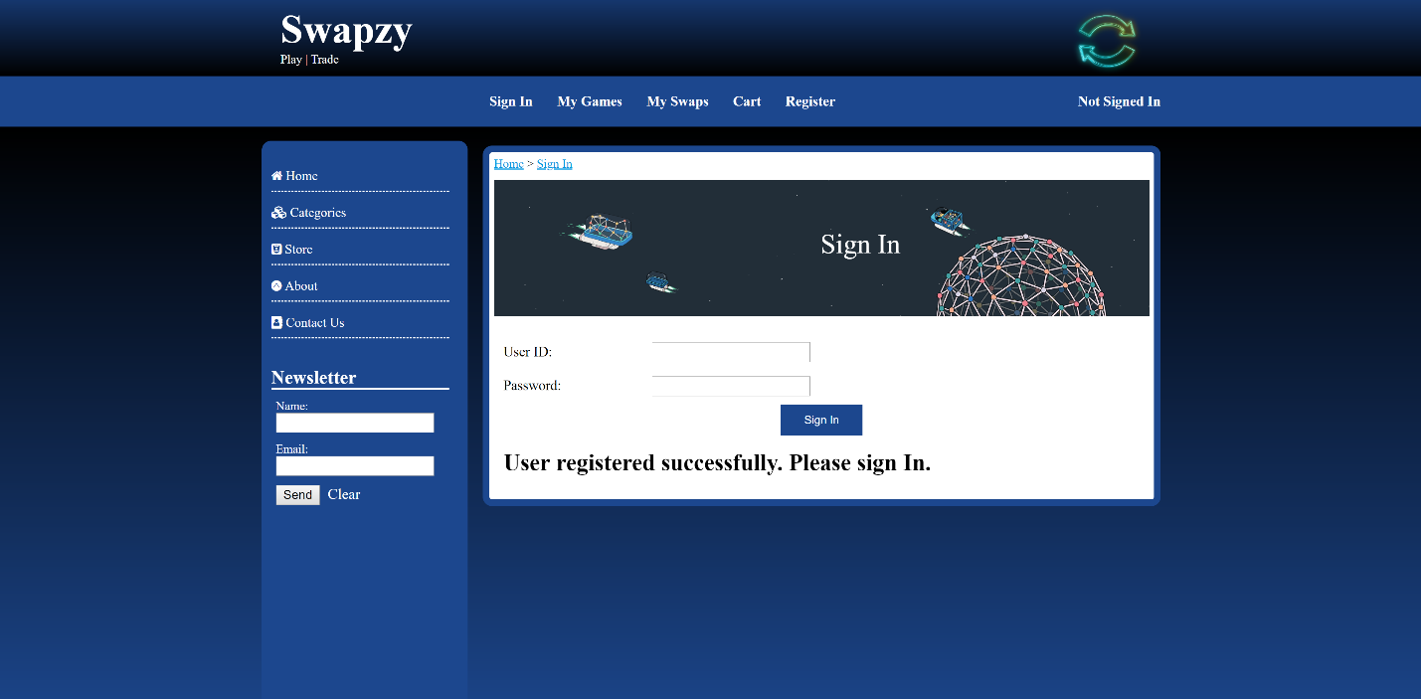

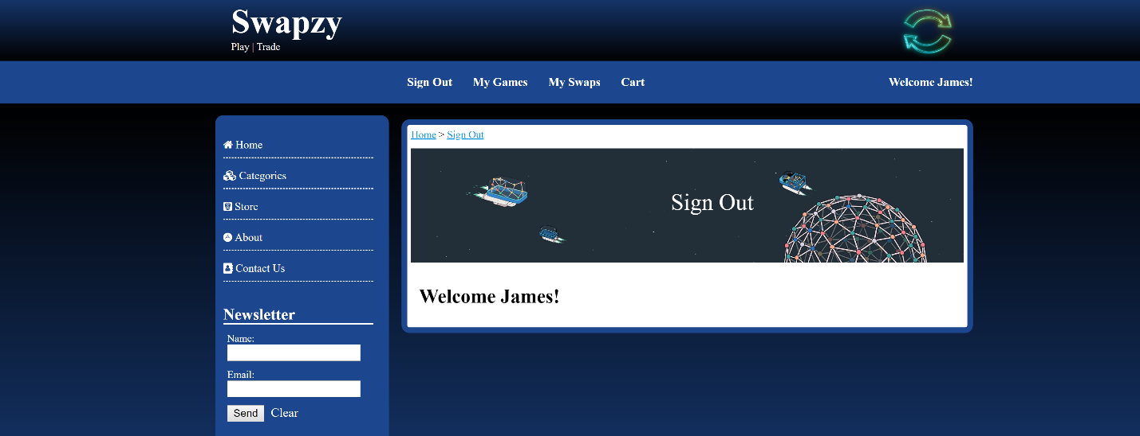

CATALOG CATEGORY

The catalog category page consists of categories of games and per category there are game items. If no user is logged in to the system, the catalog category must display all the categories and all its sub-items. If a user is logged in it should only show the items that are not belonging to that user.

The below screen shows the UI for the catalog category page:

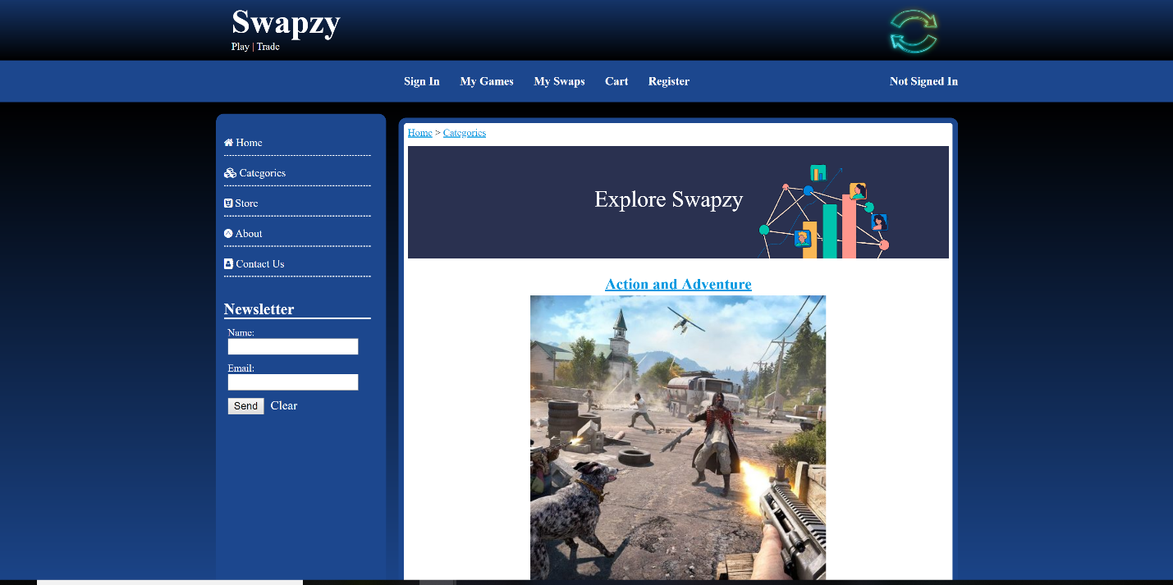

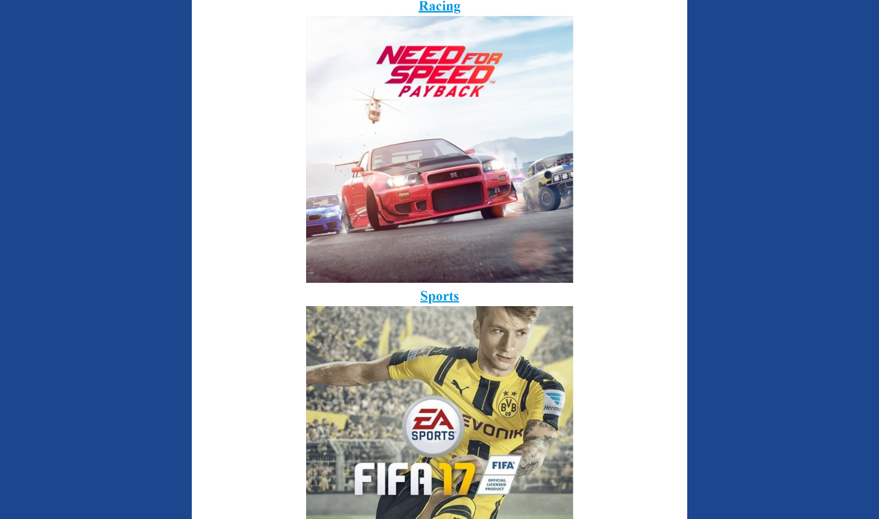

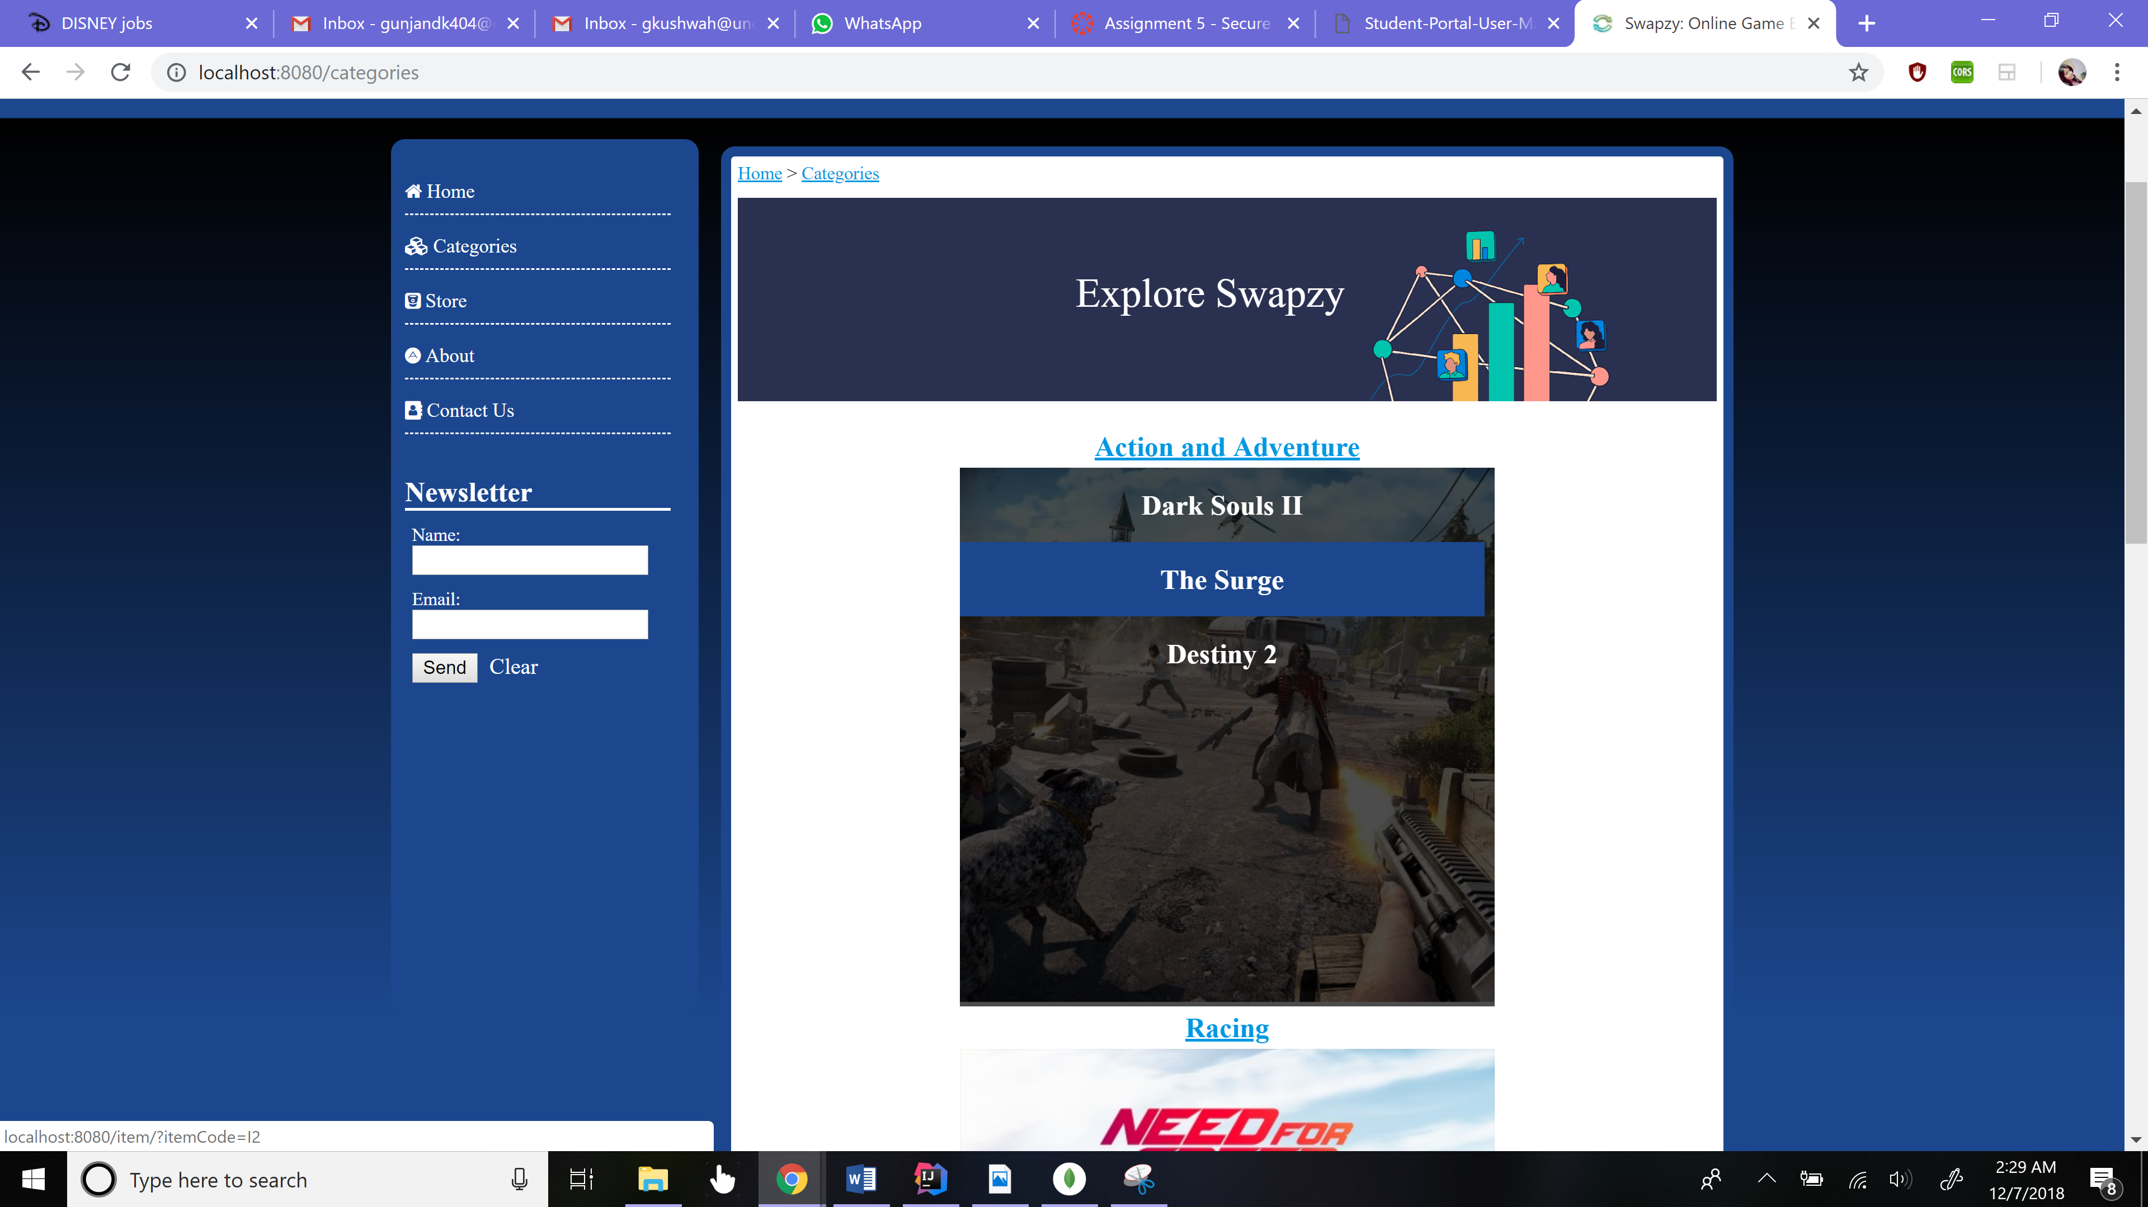

ITEMS

The individual Item Page displays the in formation about each individual item in the database. The individual item consists of Item description, an image and options to swap/rate or go back to categories page. If any item which belongs to the user is available for swap, it shows offers on that item.

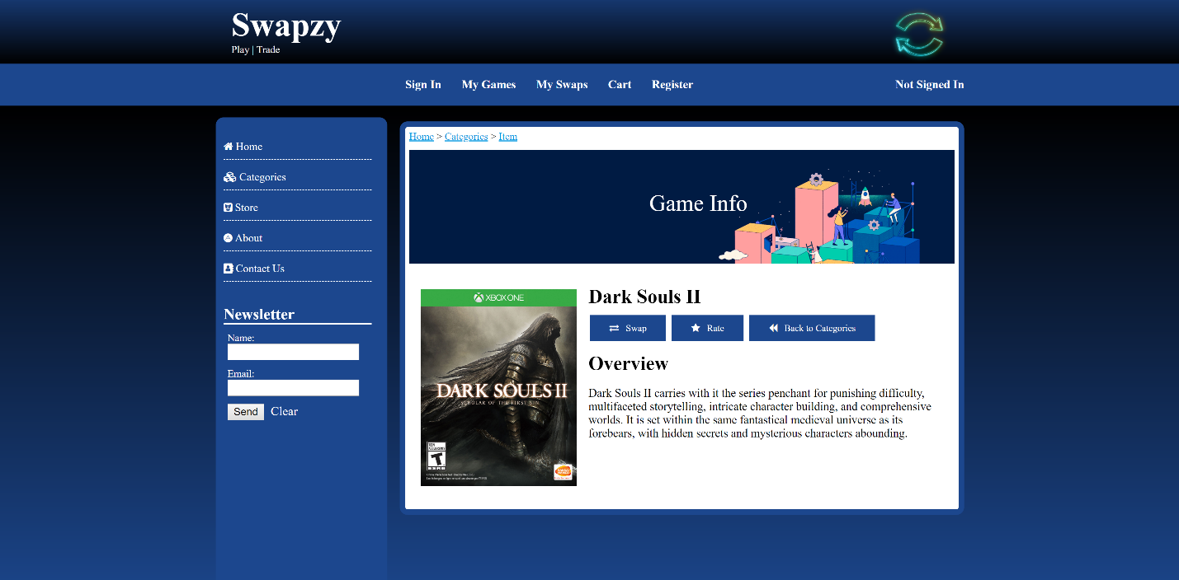

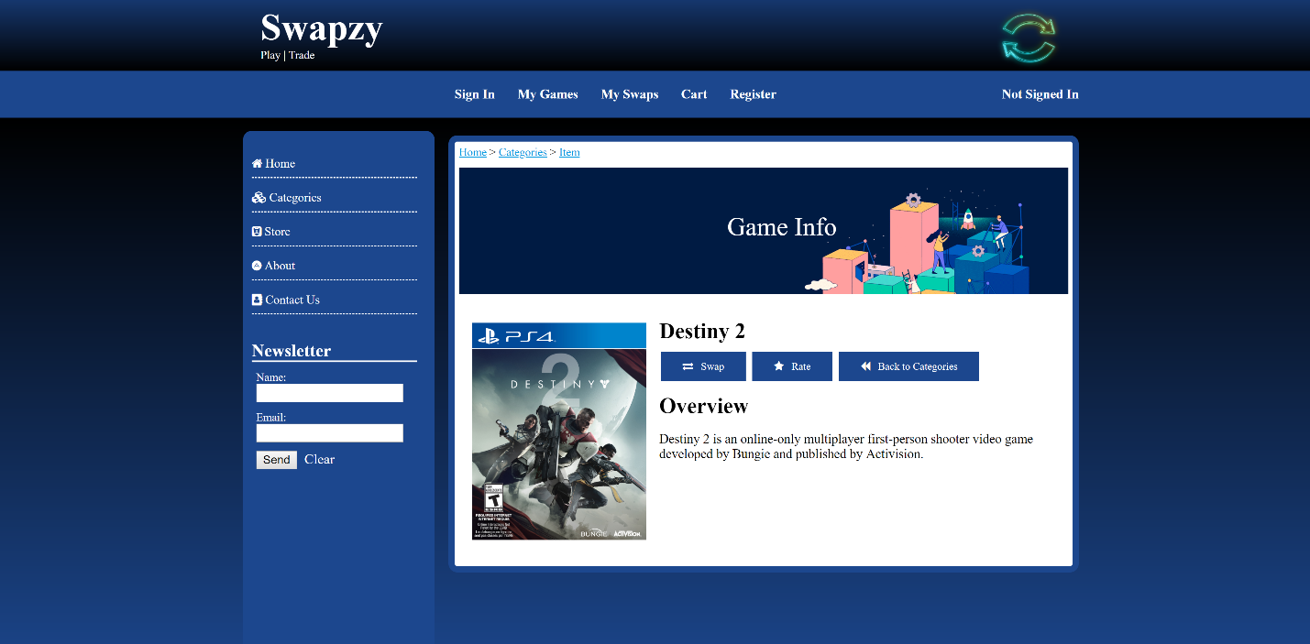

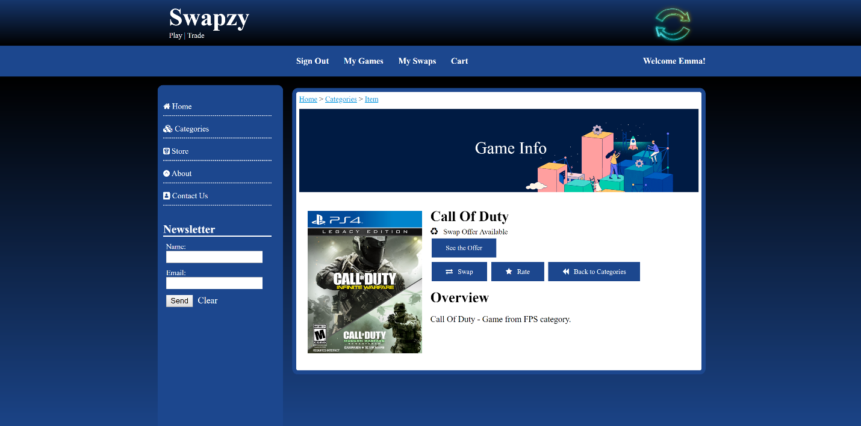

SWAPS

The swaps page tells what swapping item is available to the user. If no swap item is available, it asks the user to add items for swapping.

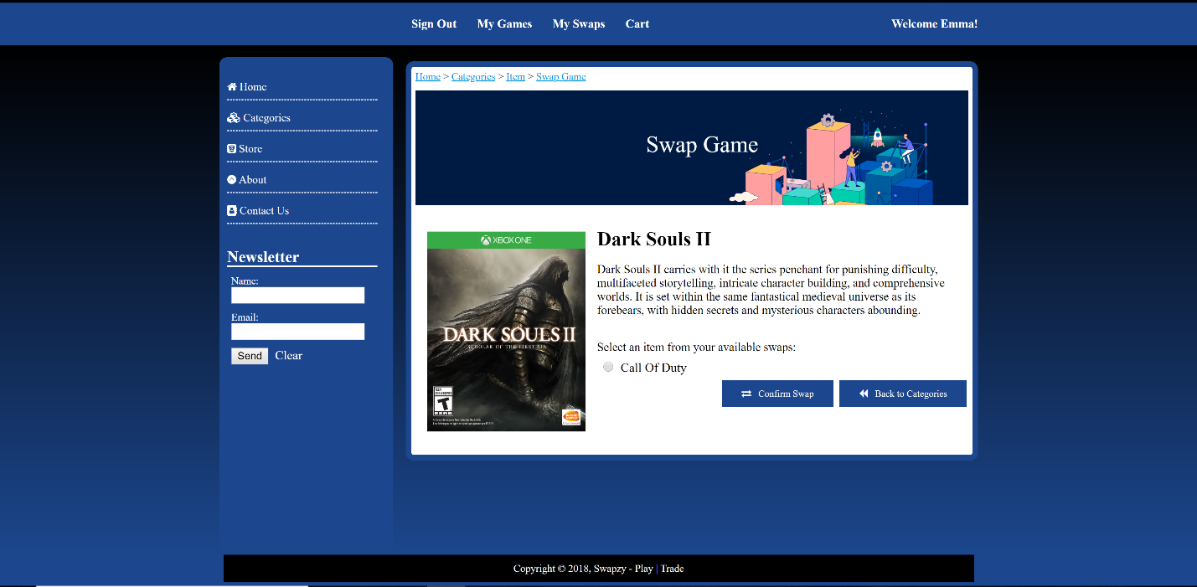

If the user is not logged in or does not have any offers available, the below message is displayed:

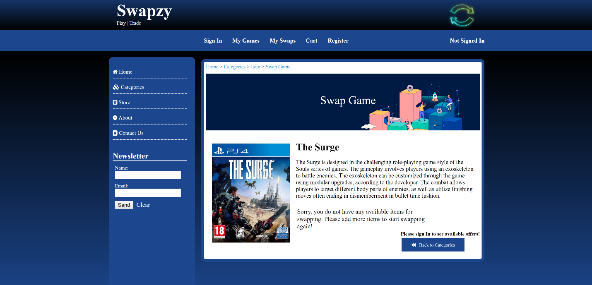

On selecting the available item and clicking on “Confirm Swap” button, the item is added to the My Swaps as well as My Items page with ‘Pending’ status. Now the user can either Accept/Reject or Withdraw this offer.

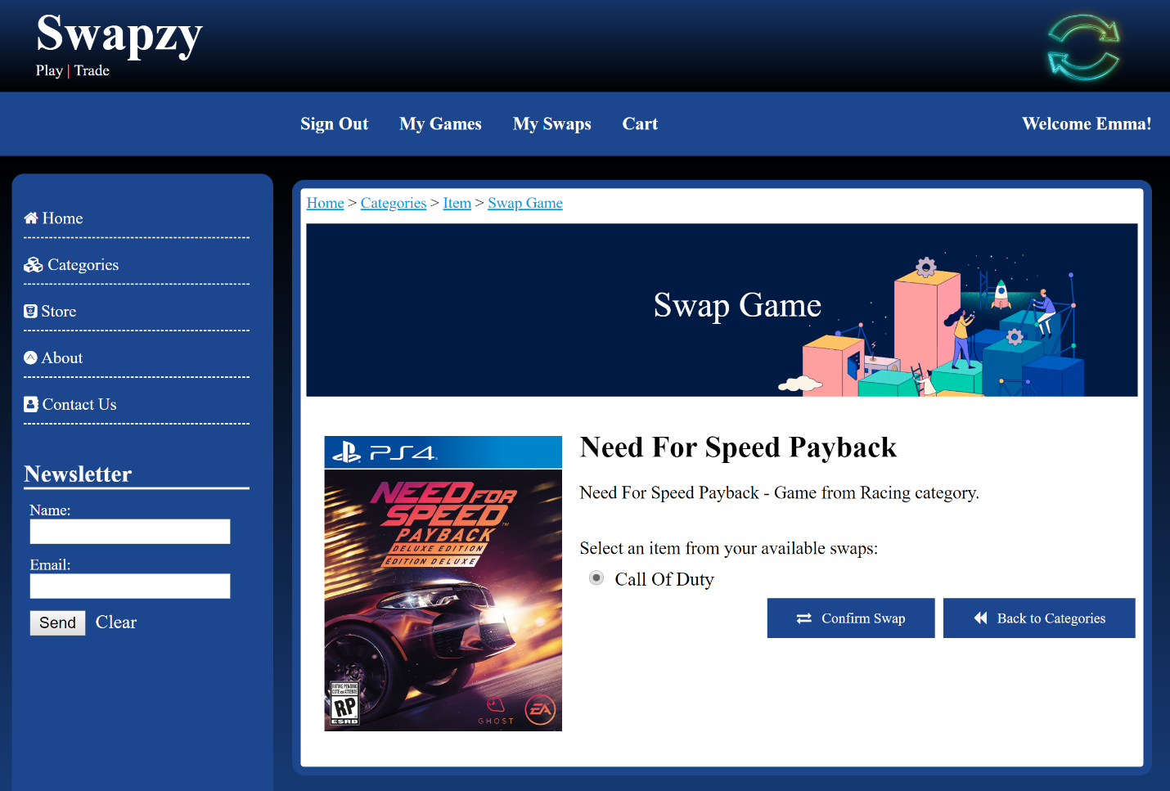

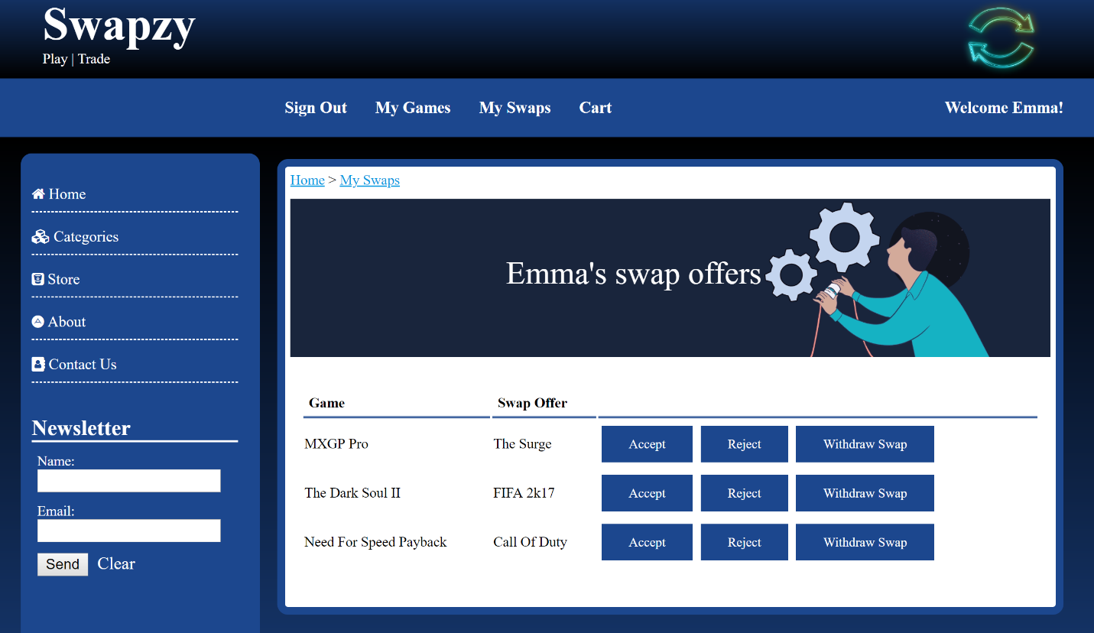

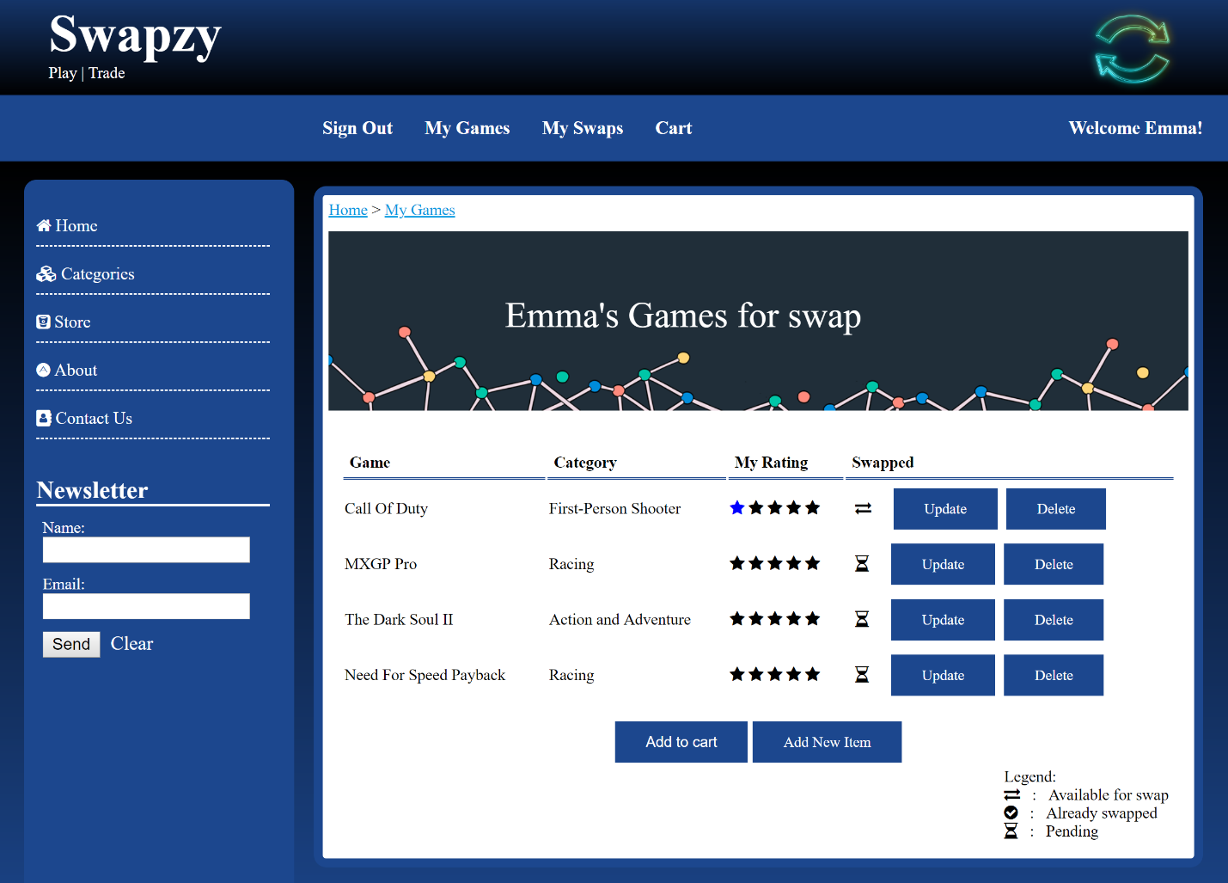

MY GAMES

This page is designed to enable users to manage their items. The status of user items is categorized into three categories: **Available, Pending** and **Swapped**.

* **Available**: An item is in ‘Available’ status when there is offer available and the user can be swapped with another item of any other user.
* **Pending**: An item is in ‘Pending’ status when the swap is made but still pending with the user for approval/acceptance.
* **Swapped**: An item is in ‘Swapped’ status when the user accepts/approved the swap from My Items Page.

My Games page provides the user an option to update or delete any item on the user list.

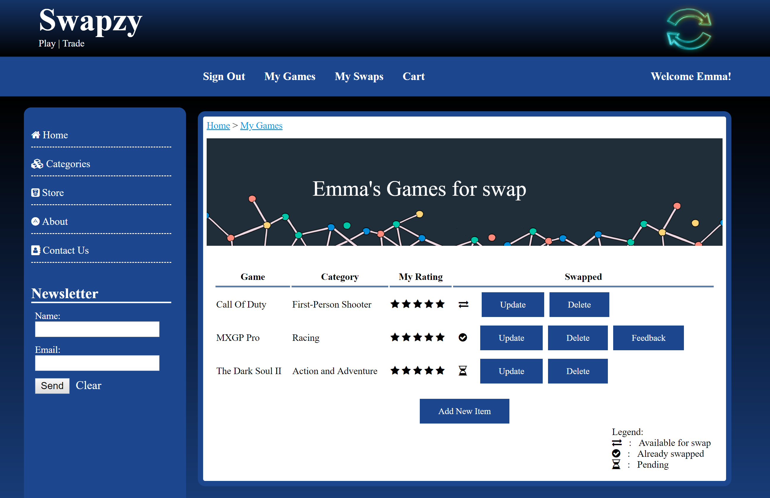

If the user clicks on ‘Update’ button, if the status of the item is ‘Available’ or ‘Swapped’– the user should be navigated to individual Item page and show the offers available (if status is ‘Available’) and notify that the item has already been swapped (if status is ‘Swapped’) and if the item status is ‘Pending’, the user should be navigated to My Items page with only that item on My Items Page. On click of ‘Delete’ button, the item corresponding to that item should be deleted.

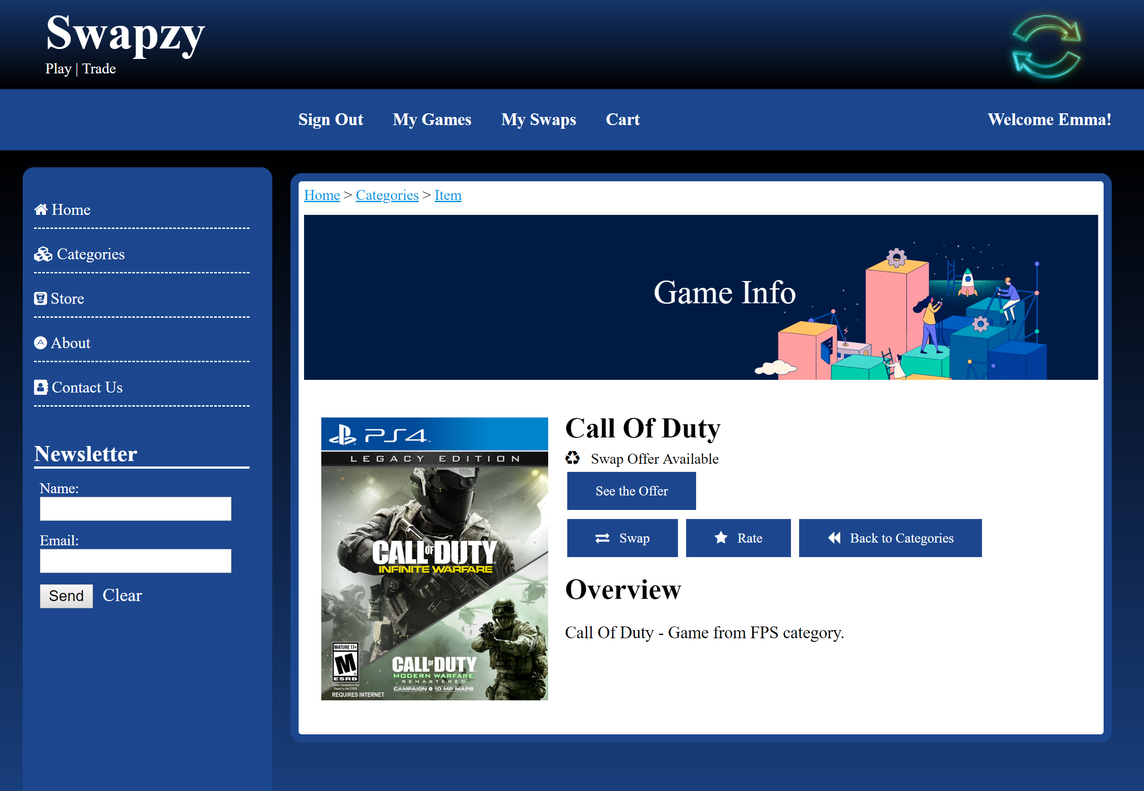

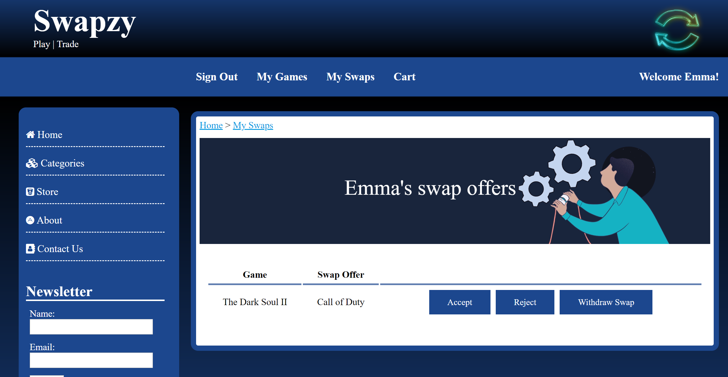

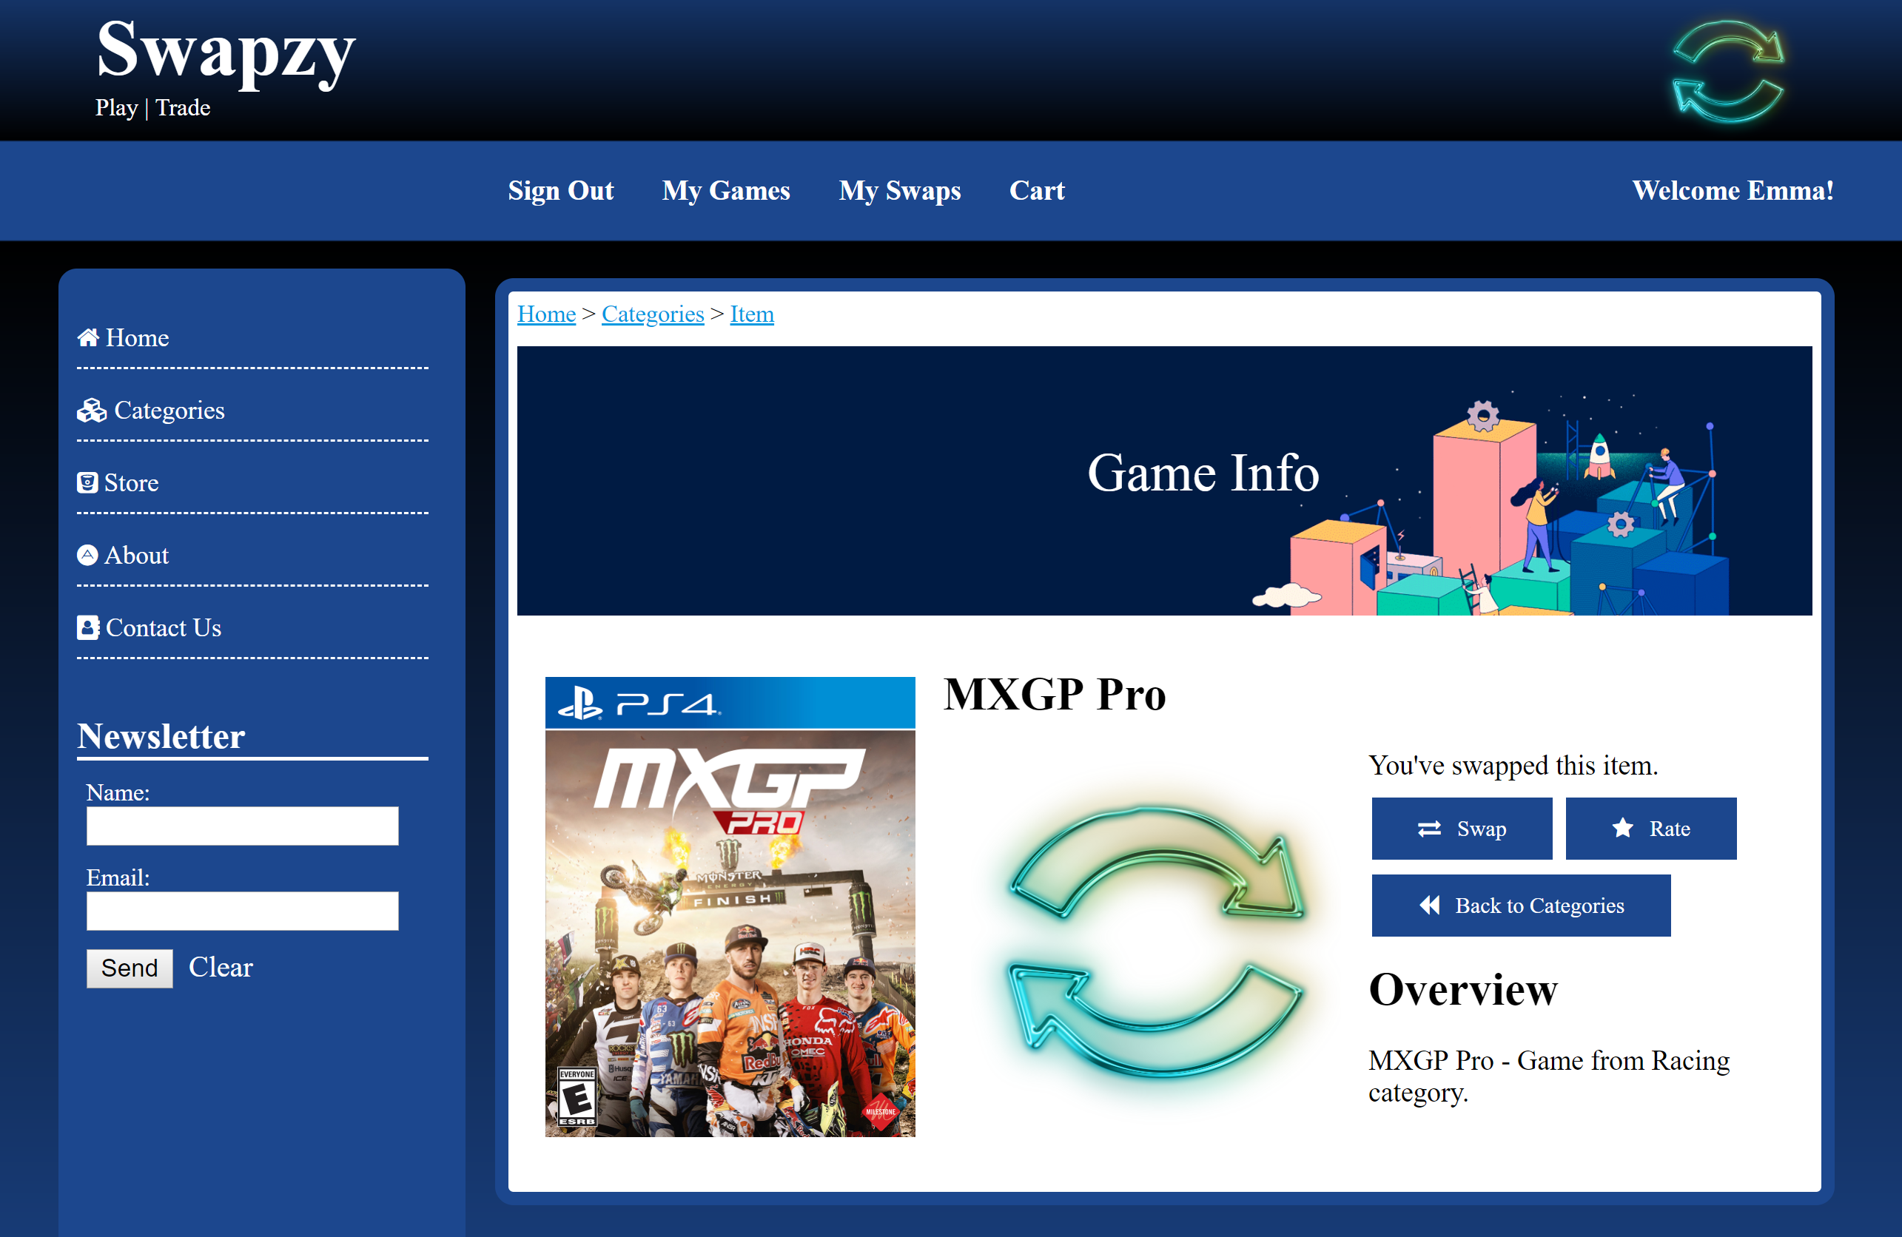

* Add New Item – If the user intends to add a new item to his/her profile, they can do so by clicking on Add New Item button on the My Games Page. The User Interface for the Add New Item is shown below:

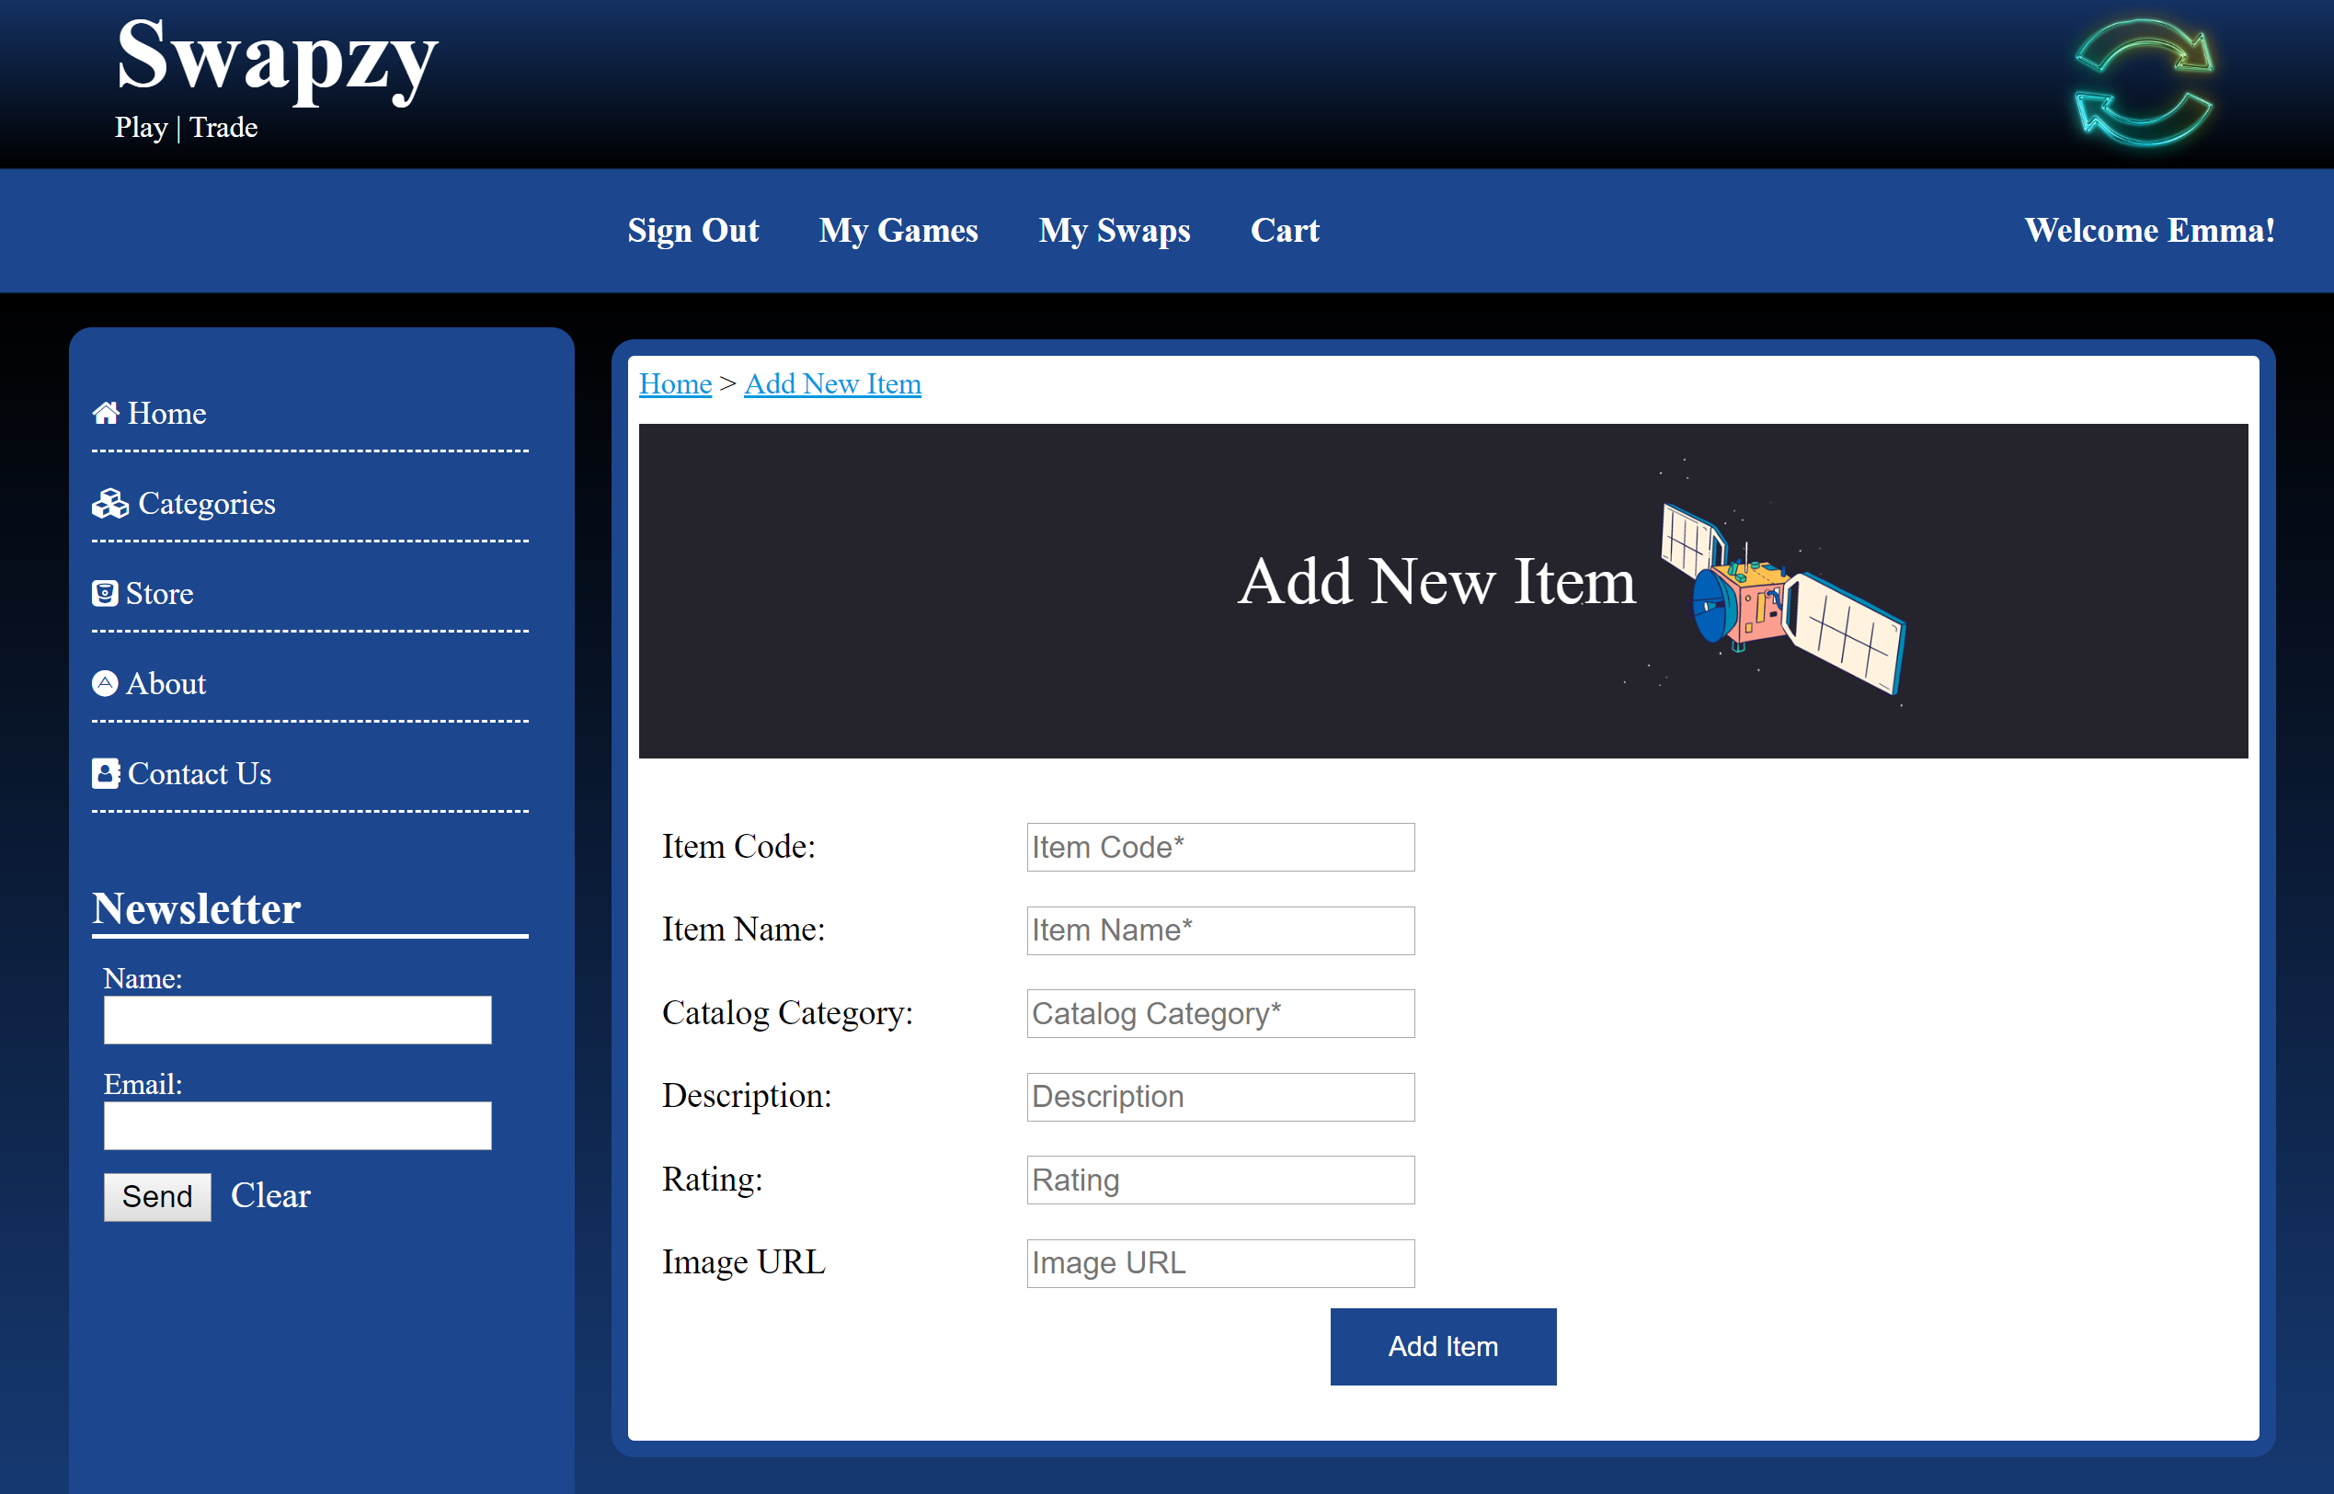

Validations on Add New Item Page:

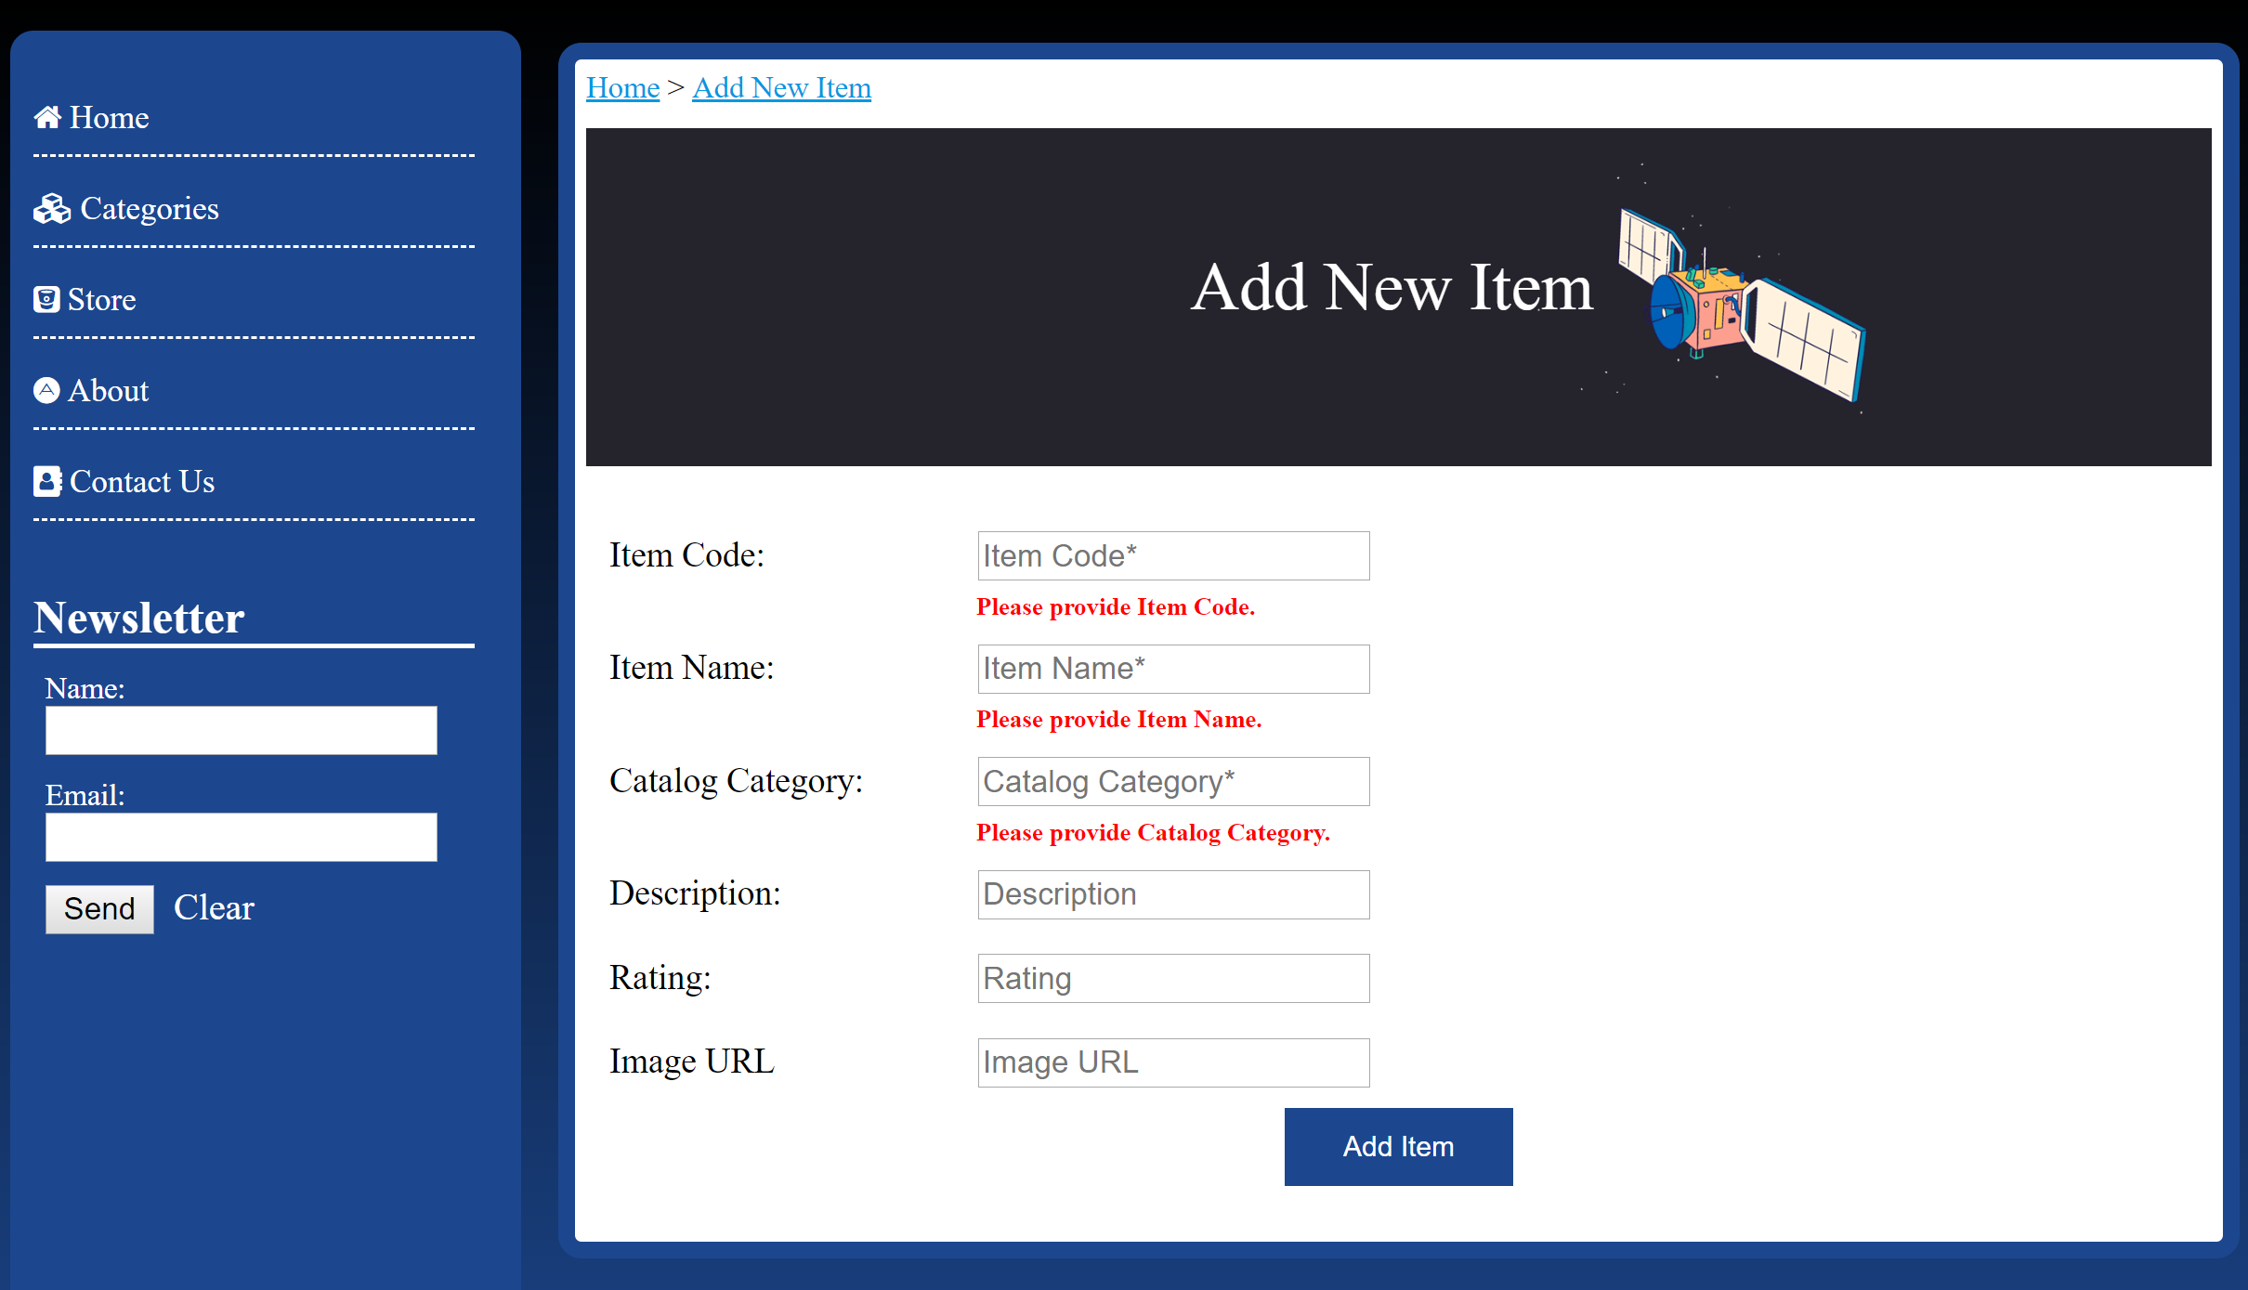

Adding New Item:

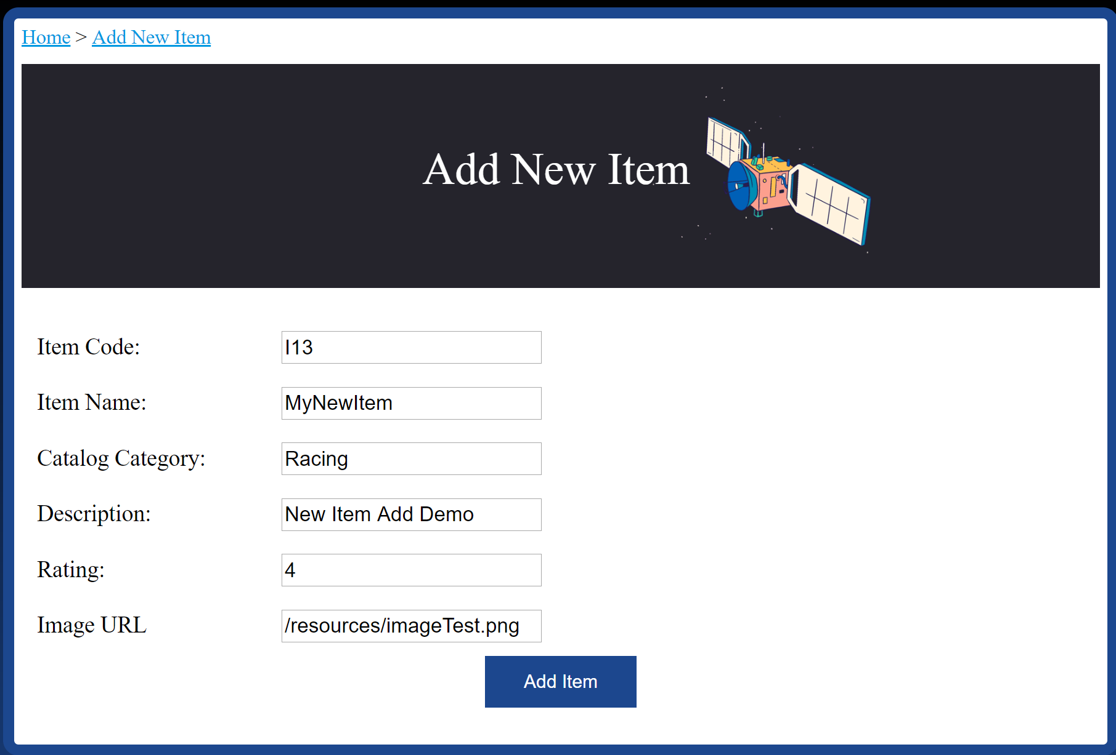

Successful addition of New Item:

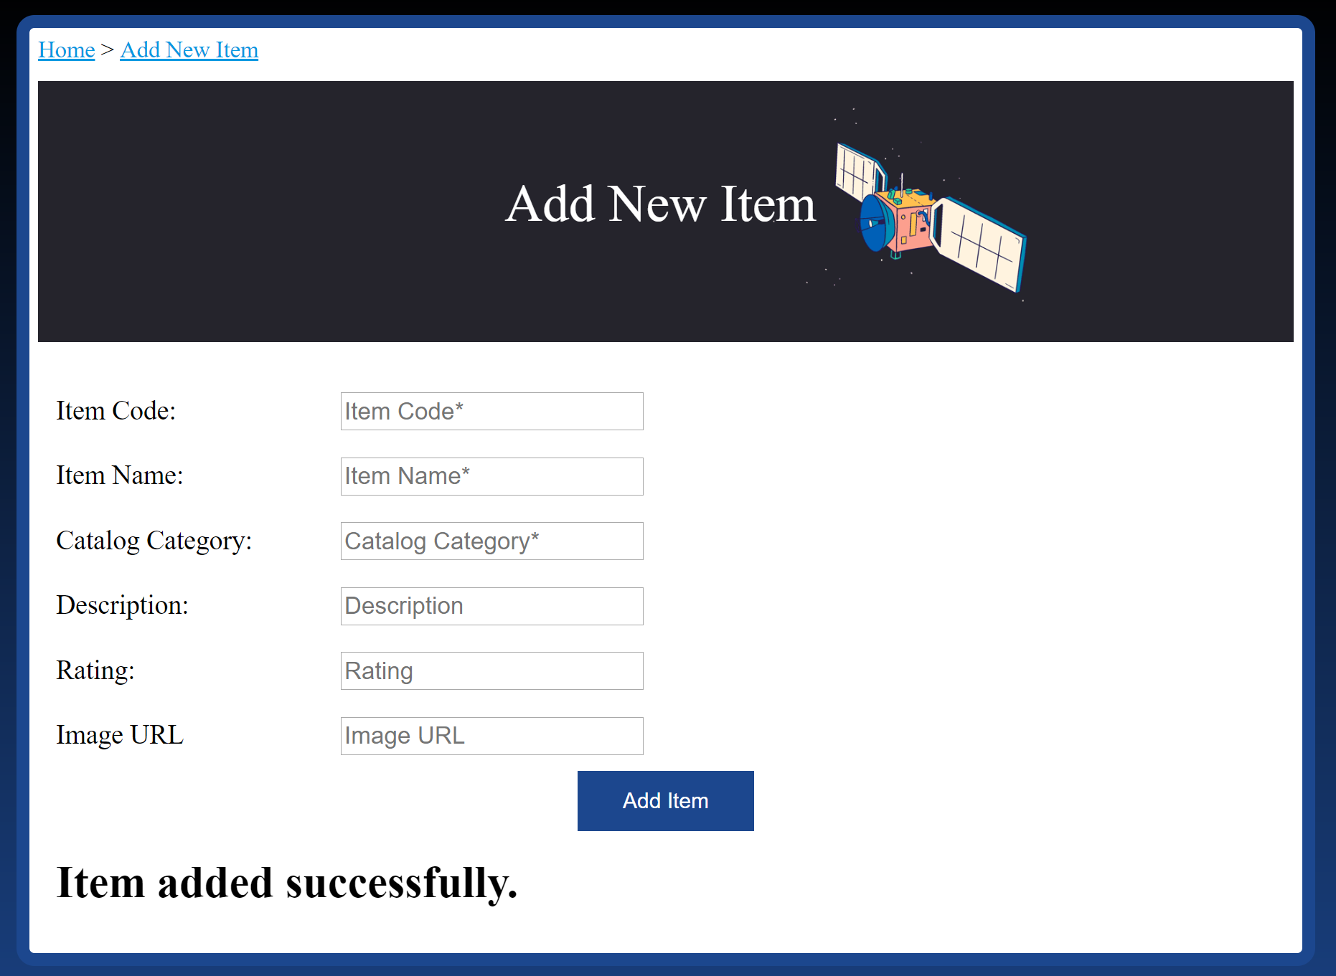

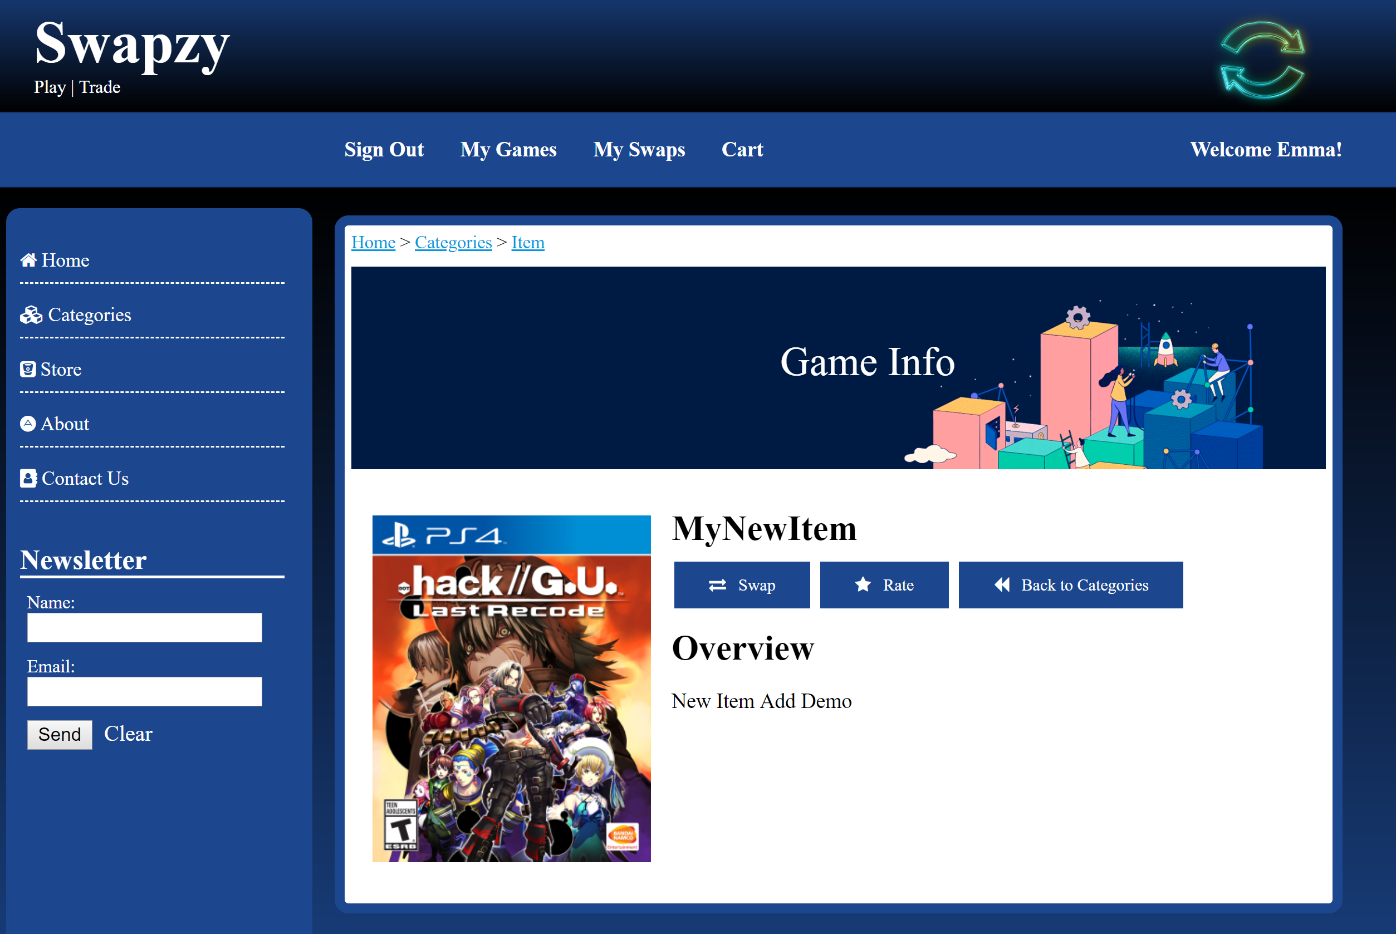

* Feedback – If the user intends to add a feedback/rating for any item/swapper rating/ swap item rating, they can do so by clicking the feedback button on My Games page. The user will be redirected to Feedback Page with only the item for which feedback button was clicked.

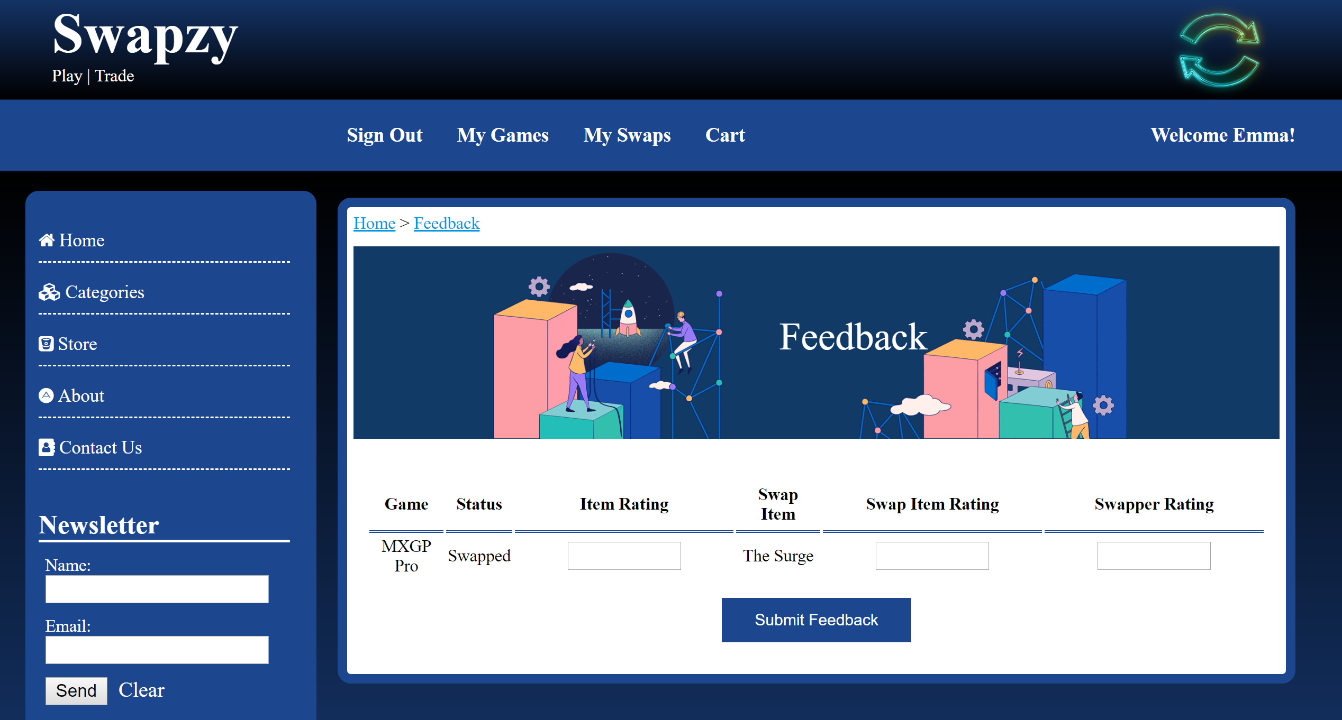

Validations on Feedback Page:

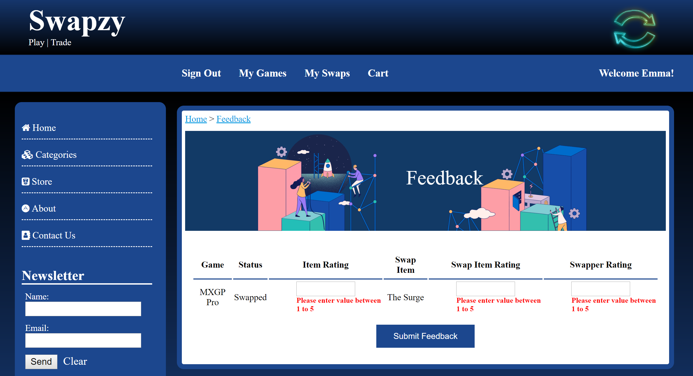

Before providing any details, suppose initial ratings were:

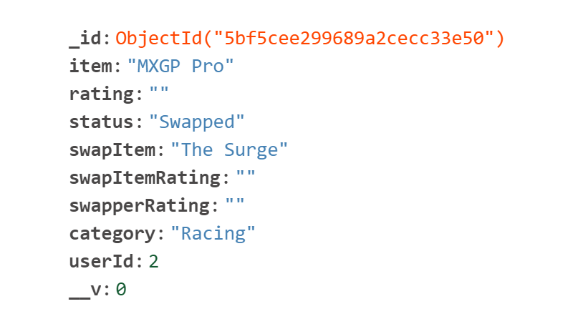

After submitting feedback ratings:

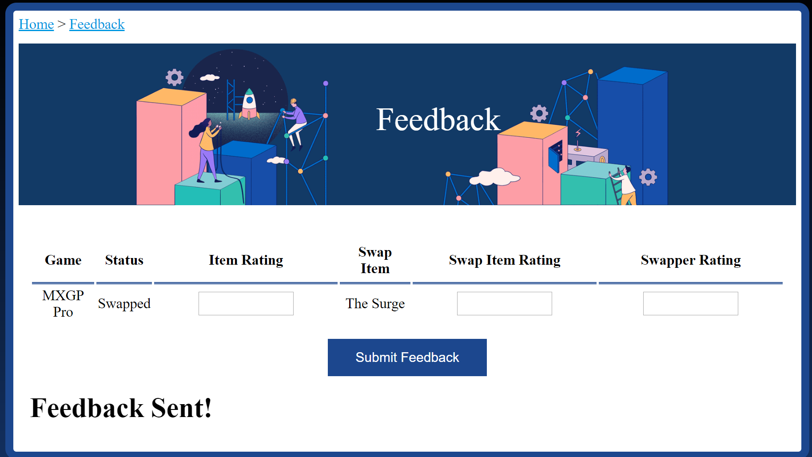

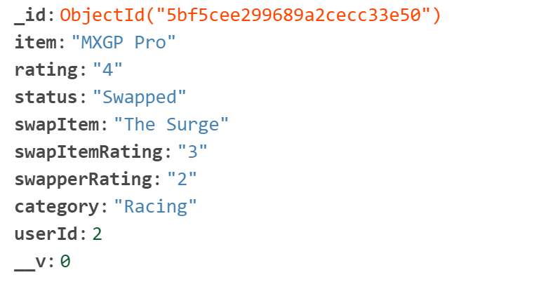

Updated ratings on My Games page:



MY SWAPS

The My Swaps page enable user to accept, reject or withdraw any offer. The My Swaps page shows only the items which are in Pending or Swapped status. Once the user accepts a Pending item, the status of the item gets changes to Swapped. If the user rejects a pending offer, the status of the user item goes back to being available and its swap details get cleared.

Initial status and data in database:

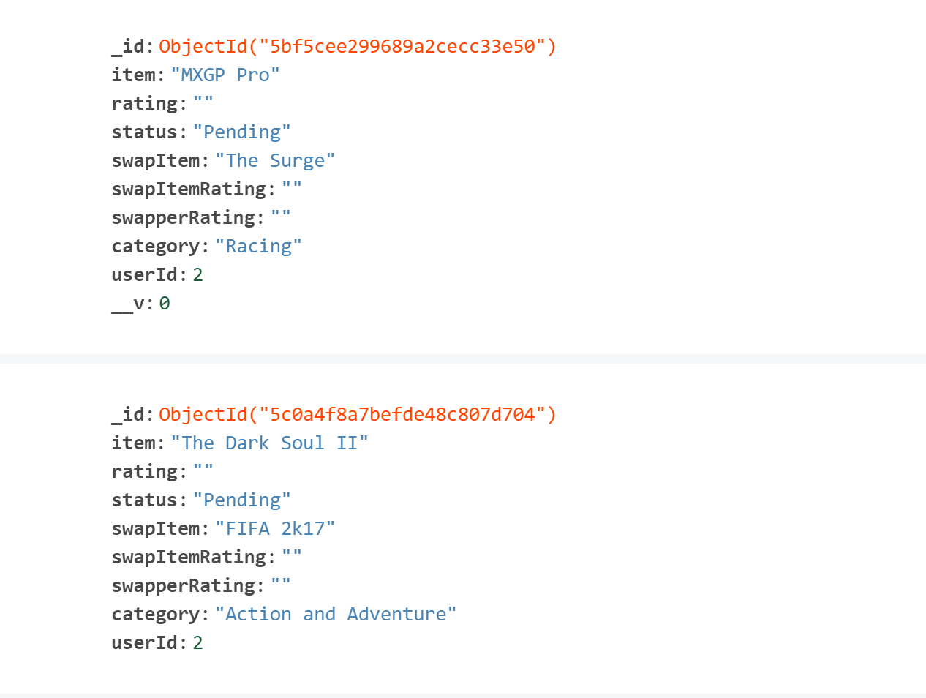

On clicking Accept:

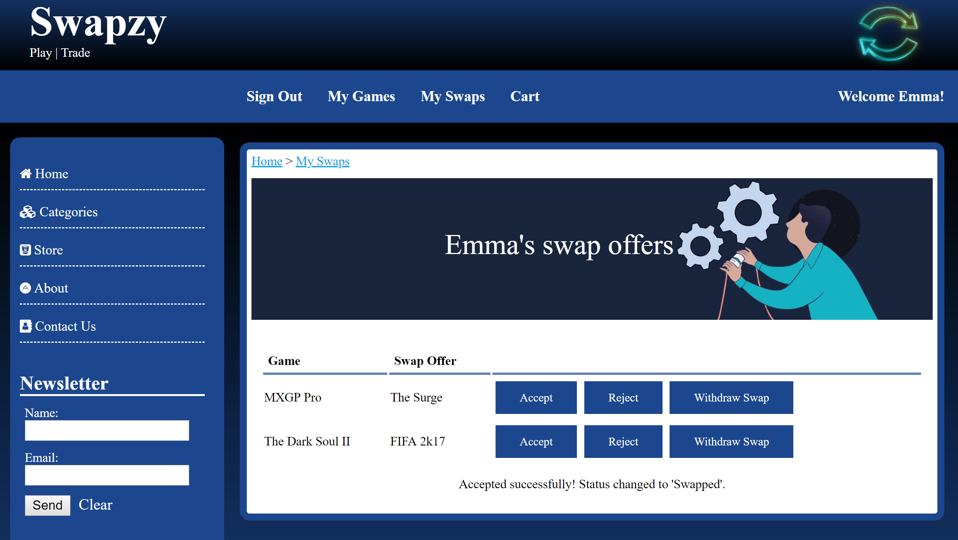

Status updated to “Swapped” in database:

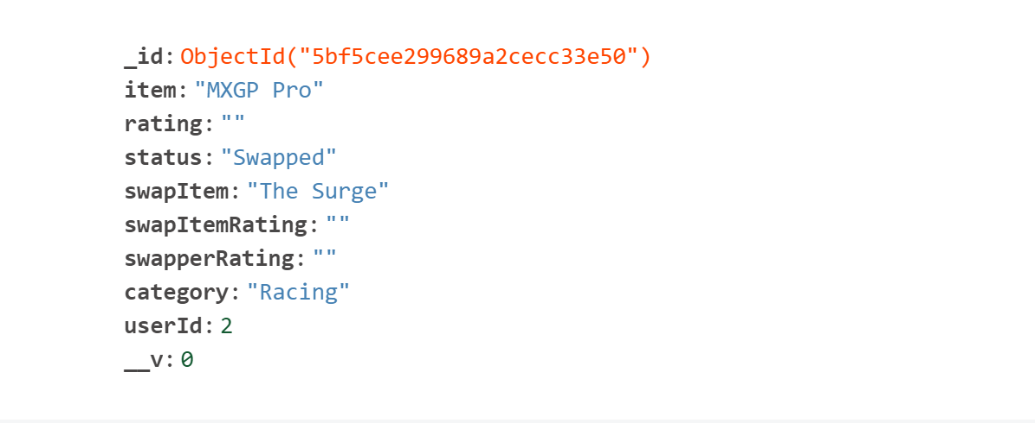

On click of reject/withdraw button:

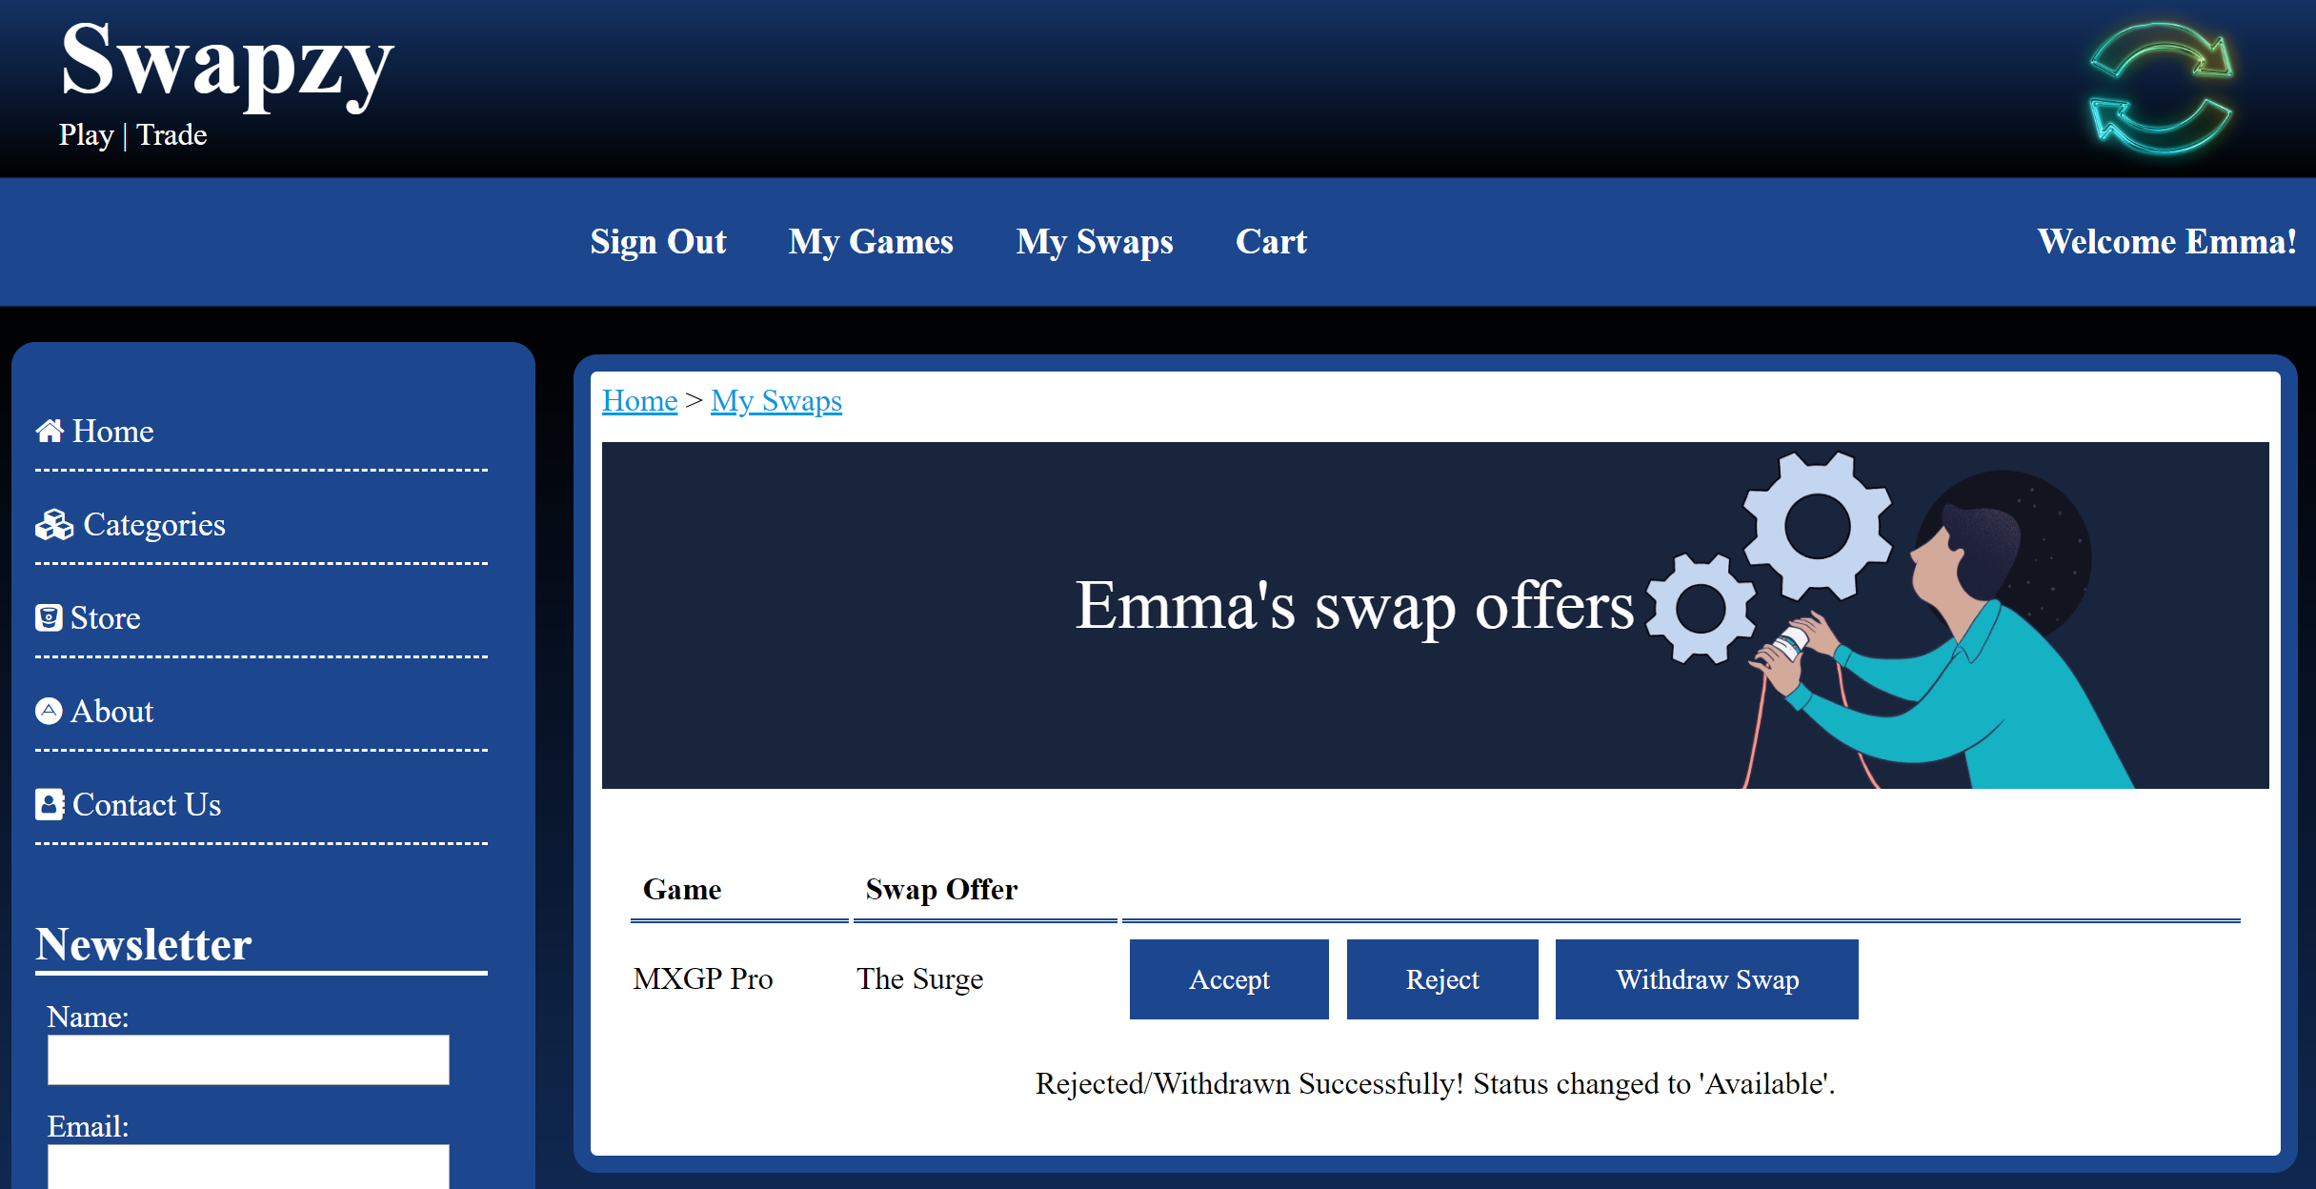

Status updated to “Available” on click of reject/withdraw:

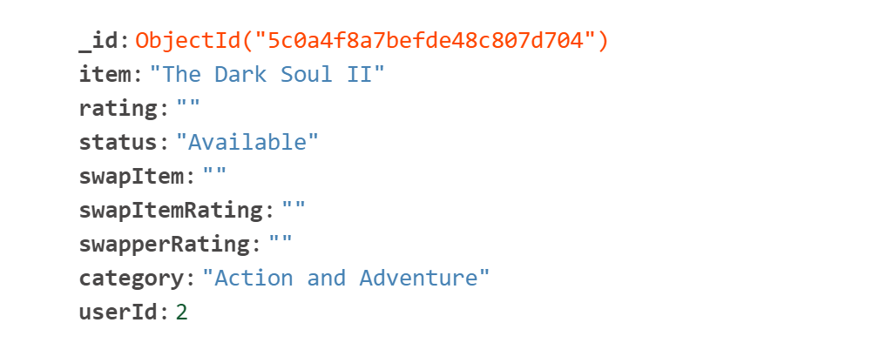

ABOUT & CONTACT

This page provides a general information about the website. Who the developers are and why have they created the website. The contact page is a dummy page with some input fields along with company’s address and email.

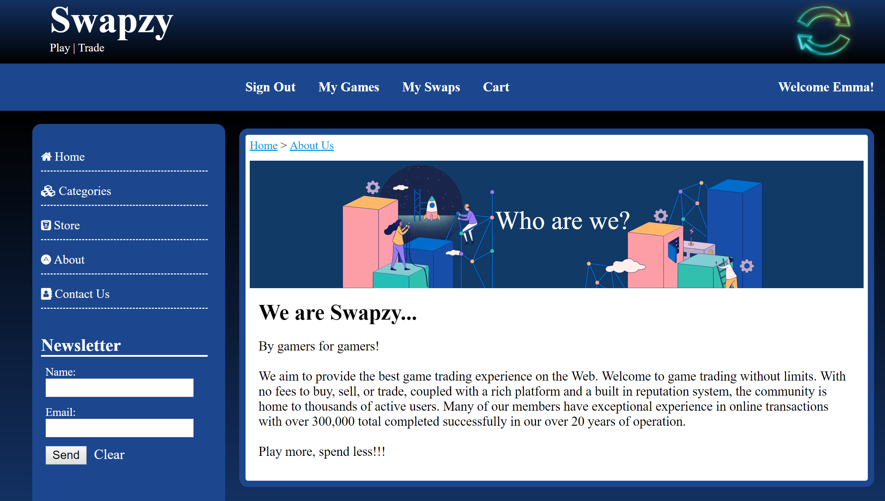

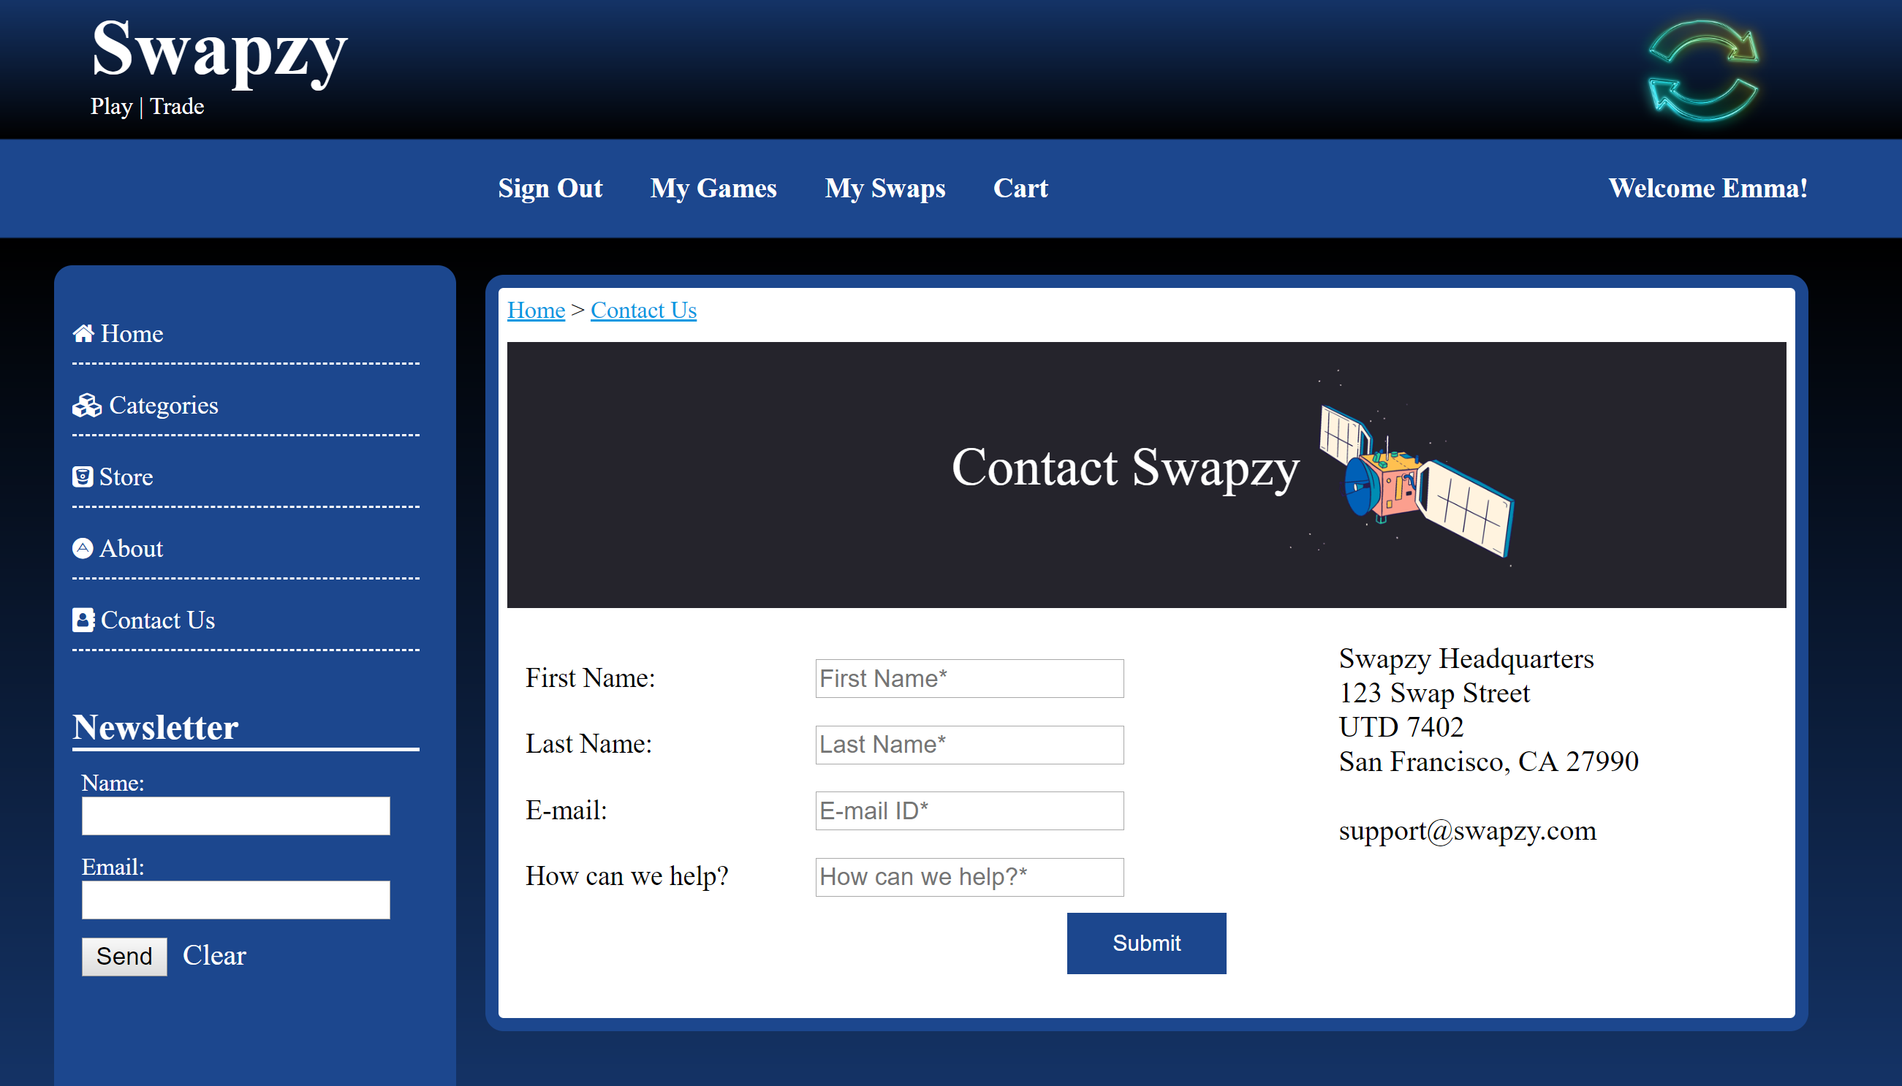

SIGN OUT

The sign out option is available only when the user is already logged in to the system. Once the user clicks on sign out present on the User-Navigation, the session gets destroyed and the user is redirected to the Catalog Category Page.

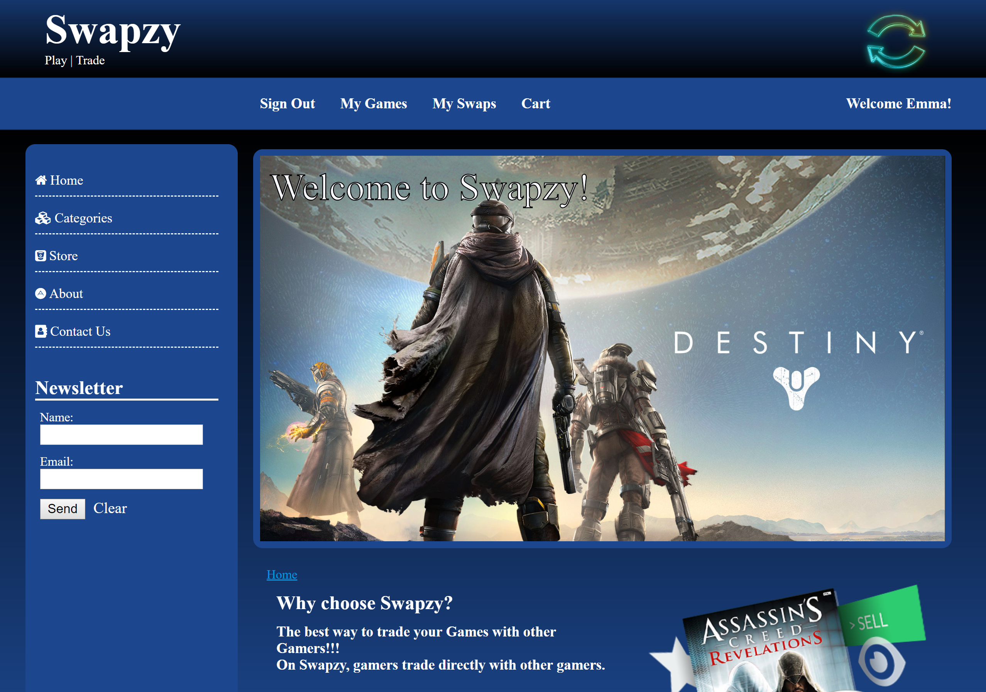

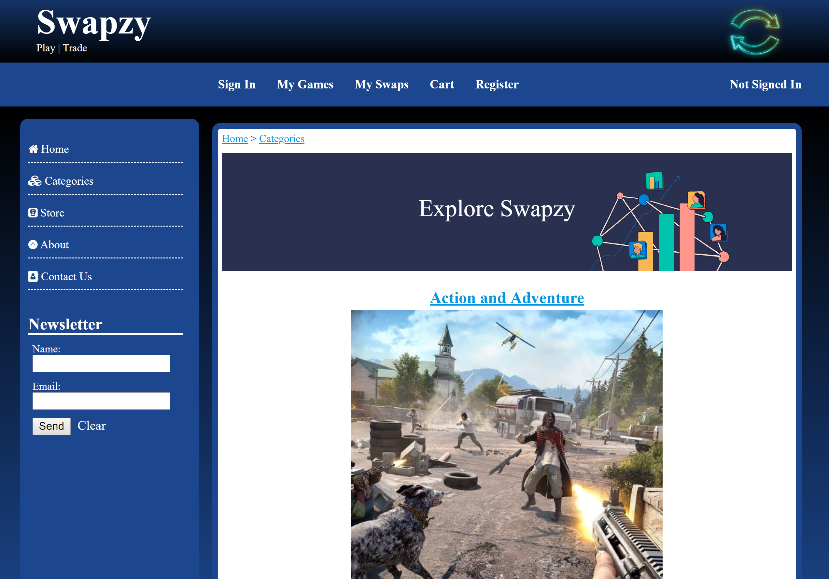

FOOTER & USER MANUAL

The footer carries only general site copyright information:

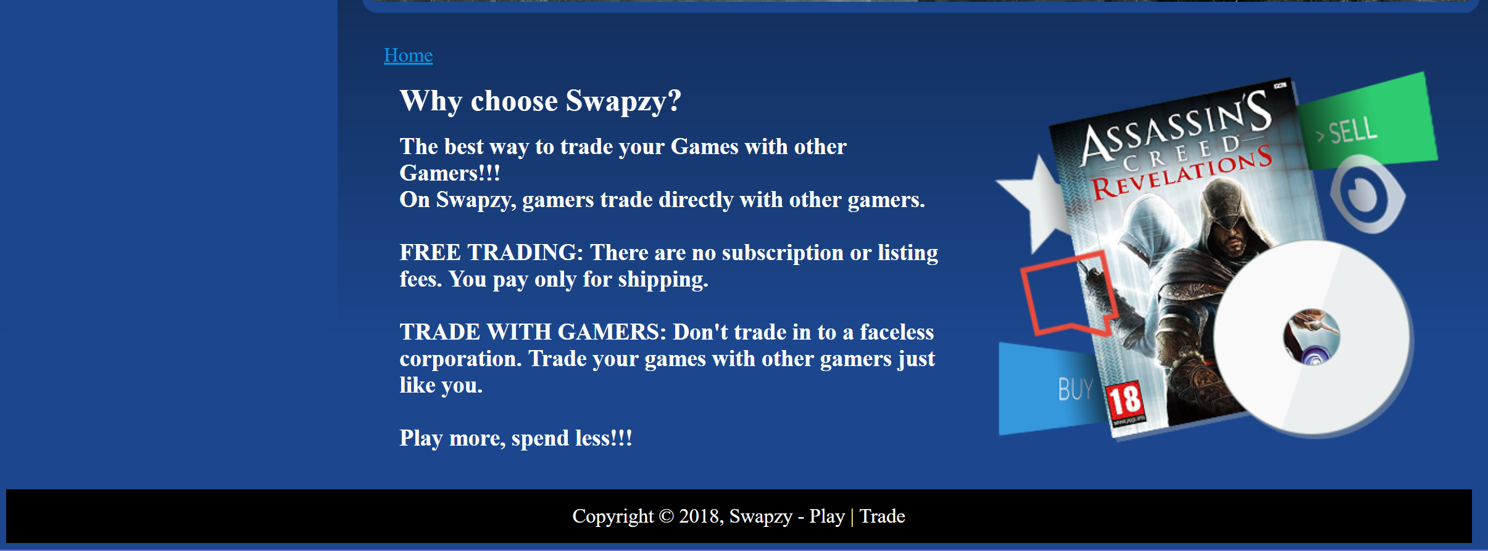

On click of User Manual in the footer section, the user manual gets downloaded:

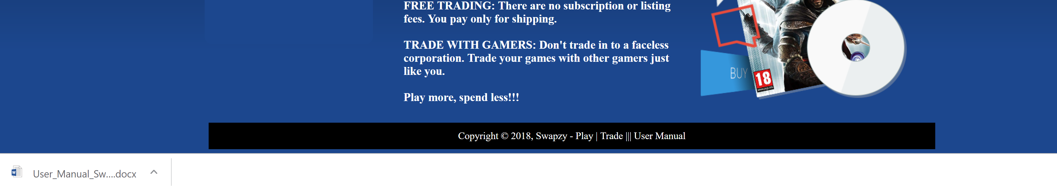

DATABASE DESIGN

The basic database design structure is given below:

